1. Deploy a Virtual Machine for creating and customizing the image
2. Make a disk Snapshot
3. Creating a Virtual Machine Capture
4. Create a Shared Image Gallery
5. Add an image to the Shared Image Gallery
6. Deploy a Windows Virtual Desktop Host pool with the custom image
7. Update the custom image (create Disk, new VM, Snapshot and VM Capture)
8. Add a version to the image in the Shared Image Gallery
9. Update the Windows Virtual Desktop Host pool with the new image

#### **Step 1 : Deploy a Virtual Machine for creating and customizing the image**

The first step is to deploy a VM for creating a custom image with, for example, all the required Line Of Business (LOB) applications and updates. For the next steps, login to the [Microsoft Azure Portal](https://portal.azure.com/).

[[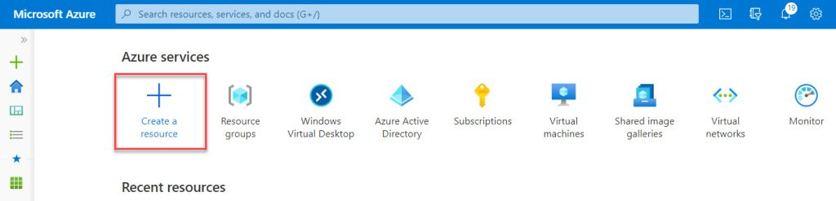](https://robinhobo.com/wp-content/uploads/2020/05/How-to-manage-and-deploy-custom-images-including-versioning-with-the-Azure-Shared-Image-Gallery-SIG-001.jpg)](https://robinhobo.com/wp-content/uploads/2020/05/How-to-manage-and-deploy-custom-images-including-versioning-with-the-Azure-Shared-Image-Gallery-SIG-001.jpg)

On the home screen of the Azure portal click **+ Create a resource**

[[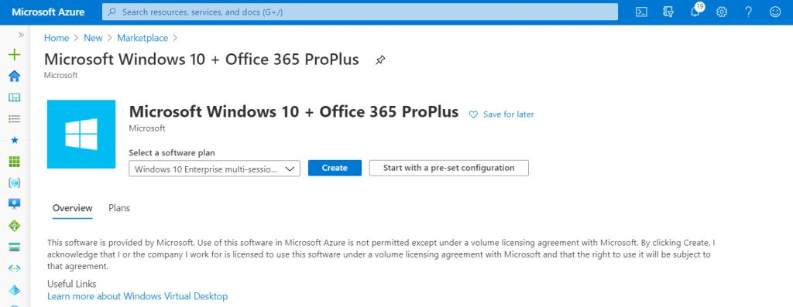](https://robinhobo.com/wp-content/uploads/2020/05/How-to-manage-and-deploy-custom-images-including-versioning-with-the-Azure-Shared-Image-Gallery-SIG-002.jpg)](https://robinhobo.com/wp-content/uploads/2020/05/How-to-manage-and-deploy-custom-images-including-versioning-with-the-Azure-Shared-Image-Gallery-SIG-002.jpg)

Search for **Microsoft Windows 10 + Office 365 ProPlus**(if you want to use a Windows 10 Multi-Session OS with Microsoft Office 365 ProPlus pre-installed on it) and click **Create**

[[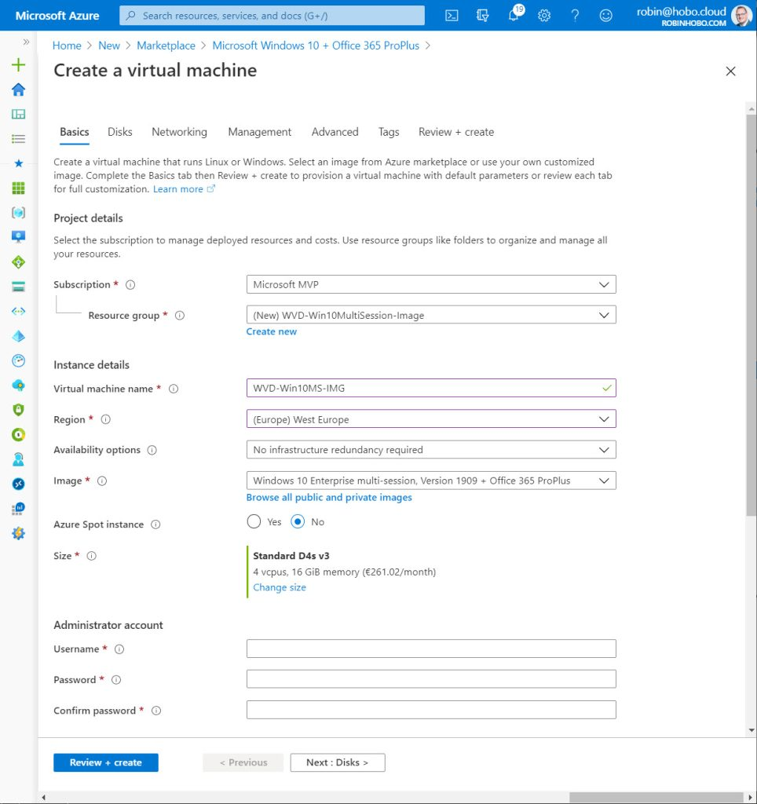](https://robinhobo.com/wp-content/uploads/2020/05/How-to-manage-and-deploy-custom-images-including-versioning-with-the-Azure-Shared-Image-Gallery-SIG-003.jpg)](https://robinhobo.com/wp-content/uploads/2020/05/How-to-manage-and-deploy-custom-images-including-versioning-with-the-Azure-Shared-Image-Gallery-SIG-003.jpg)

Select your **Subscription** and create a new **Resource group**. Give the VM a name, select **Region** and a **VM Size**. Fill in the information for the local admin account and click **Next : Disks**

[[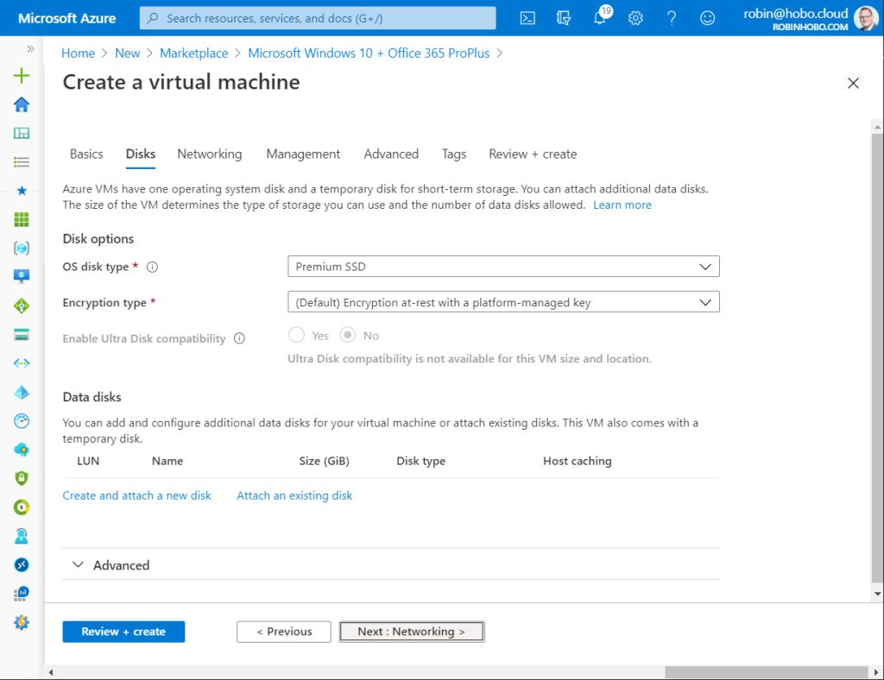](https://robinhobo.com/wp-content/uploads/2020/05/How-to-manage-and-deploy-custom-images-including-versioning-with-the-Azure-Shared-Image-Gallery-SIG-004.jpg)](https://robinhobo.com/wp-content/uploads/2020/05/How-to-manage-and-deploy-custom-images-including-versioning-with-the-Azure-Shared-Image-Gallery-SIG-004.jpg)

Select **Premium SSD** and click **Next : Networking**

[[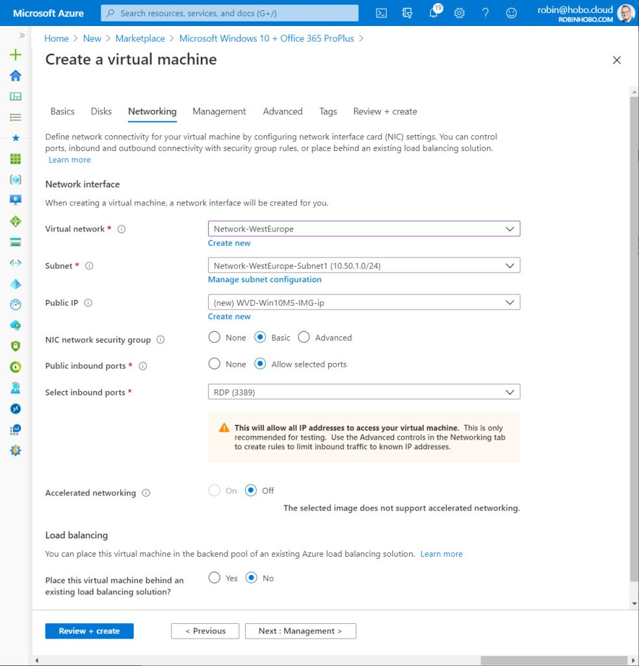](https://robinhobo.com/wp-content/uploads/2020/05/How-to-manage-and-deploy-custom-images-including-versioning-with-the-Azure-Shared-Image-Gallery-SIG-005.jpg)](https://robinhobo.com/wp-content/uploads/2020/05/How-to-manage-and-deploy-custom-images-including-versioning-with-the-Azure-Shared-Image-Gallery-SIG-005.jpg)

Select the correct **Virtual network** and **Subnet** and click **Next : Management**

[[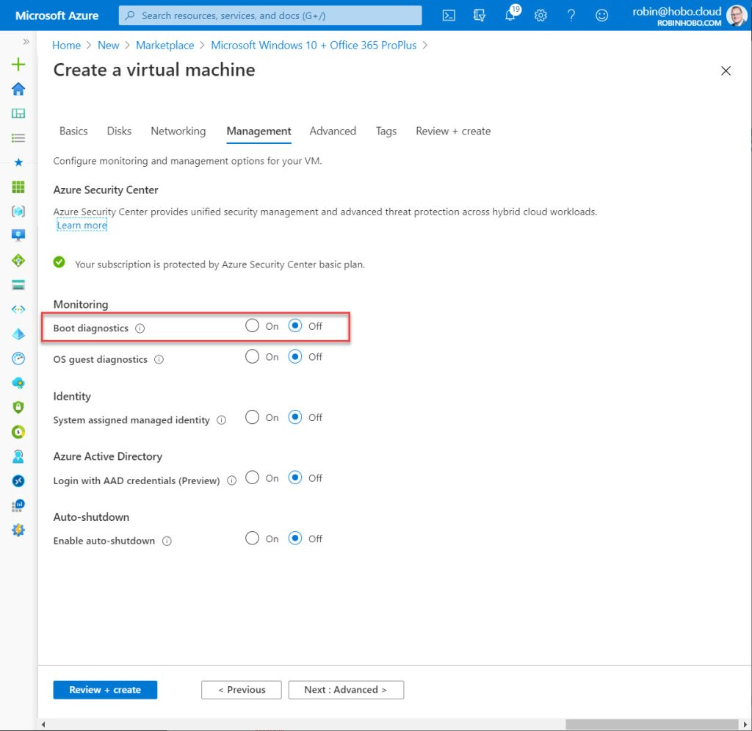](https://robinhobo.com/wp-content/uploads/2020/05/How-to-manage-and-deploy-custom-images-including-versioning-with-the-Azure-Shared-Image-Gallery-SIG-006.jpg)](https://robinhobo.com/wp-content/uploads/2020/05/How-to-manage-and-deploy-custom-images-including-versioning-with-the-Azure-Shared-Image-Gallery-SIG-006.jpg)

Turn off the **Boot diagnostics**. Click **Review + create**

[[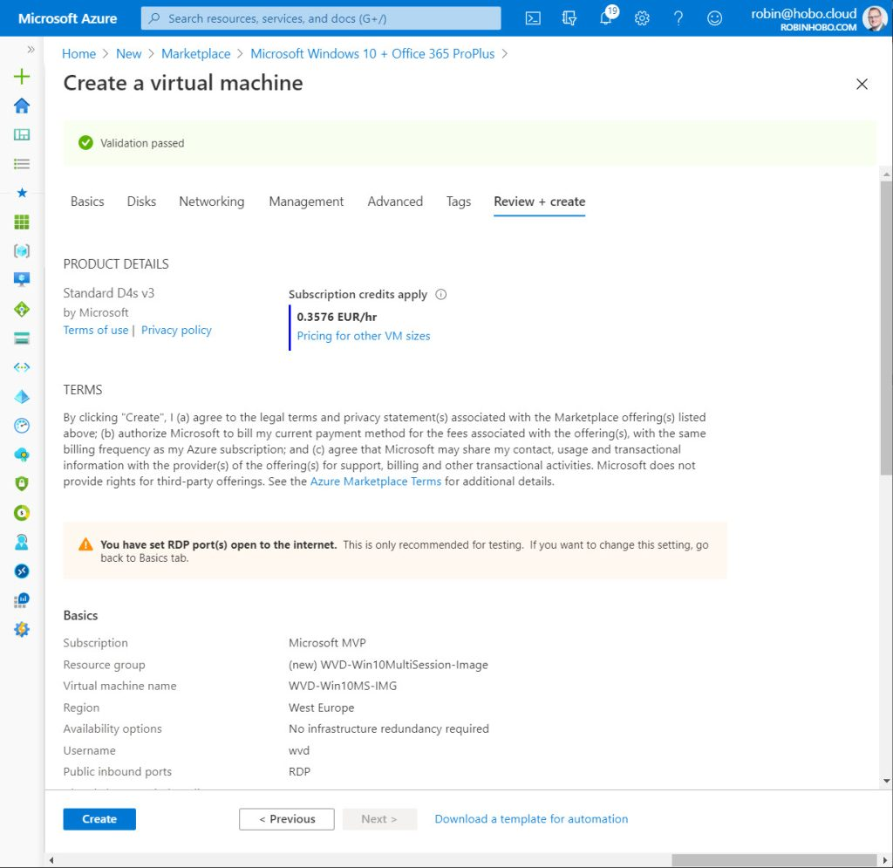](https://robinhobo.com/wp-content/uploads/2020/05/How-to-manage-and-deploy-custom-images-including-versioning-with-the-Azure-Shared-Image-Gallery-SIG-007.jpg)](https://robinhobo.com/wp-content/uploads/2020/05/How-to-manage-and-deploy-custom-images-including-versioning-with-the-Azure-Shared-Image-Gallery-SIG-007.jpg)

Click **Create**

[[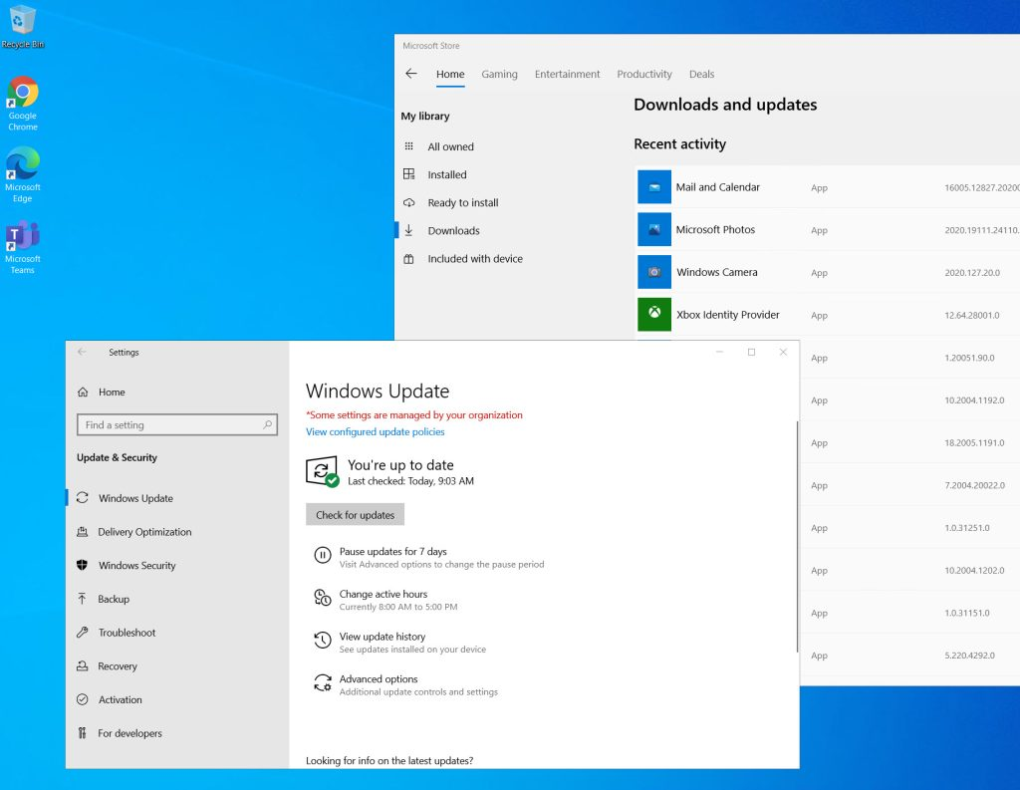](https://robinhobo.com/wp-content/uploads/2020/05/How-to-manage-and-deploy-custom-images-including-versioning-with-the-Azure-Shared-Image-Gallery-SIG-008.jpg)](https://robinhobo.com/wp-content/uploads/2020/05/How-to-manage-and-deploy-custom-images-including-versioning-with-the-Azure-Shared-Image-Gallery-SIG-008.jpg)

Connect to the Virtual Machine and install the required LOB applications. Also think about Windows and Store updates. When your finished with the installation and configurations, shut down the Virtual Machine.

#### **Step 2 : Make a disk Snapshot**

Windows 10 allows us to [run Sysprep 1001 times.](https://docs.microsoft.com/en-us/windows-hardware/manufacture/desktop/sysprep--generalize--a-windows-installation) Therefor it is not required to make a snapshot before running Sysprep, but its recommended to have the option to go back to an older version of your image. You can do this with a disk Snapshot where you can create a new VM of (see next steps in this blog). Therefor it is a good moment to make a disk Snapshot after every update like in this case.

Make sure the Virtual Machine have the **Stopped** (or deallocated) status,

[[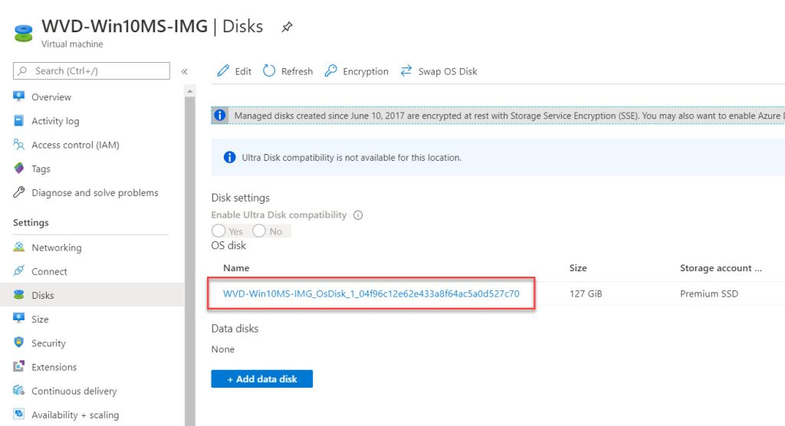](https://robinhobo.com/wp-content/uploads/2020/05/How-to-manage-and-deploy-custom-images-including-versioning-with-the-Azure-Shared-Image-Gallery-SIG-009.jpg)](https://robinhobo.com/wp-content/uploads/2020/05/How-to-manage-and-deploy-custom-images-including-versioning-with-the-Azure-Shared-Image-Gallery-SIG-009.jpg)

Open the Virtual Machine and go to the **Disk** blade. Next, click on the **OS Disk**.

[[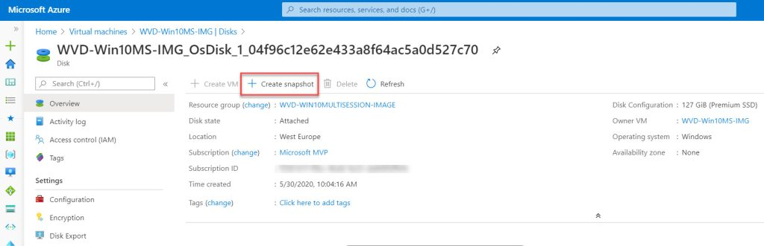](https://robinhobo.com/wp-content/uploads/2020/05/How-to-manage-and-deploy-custom-images-including-versioning-with-the-Azure-Shared-Image-Gallery-SIG-010.jpg)](https://robinhobo.com/wp-content/uploads/2020/05/How-to-manage-and-deploy-custom-images-including-versioning-with-the-Azure-Shared-Image-Gallery-SIG-010.jpg)

Click **+ Create snapshot**

[[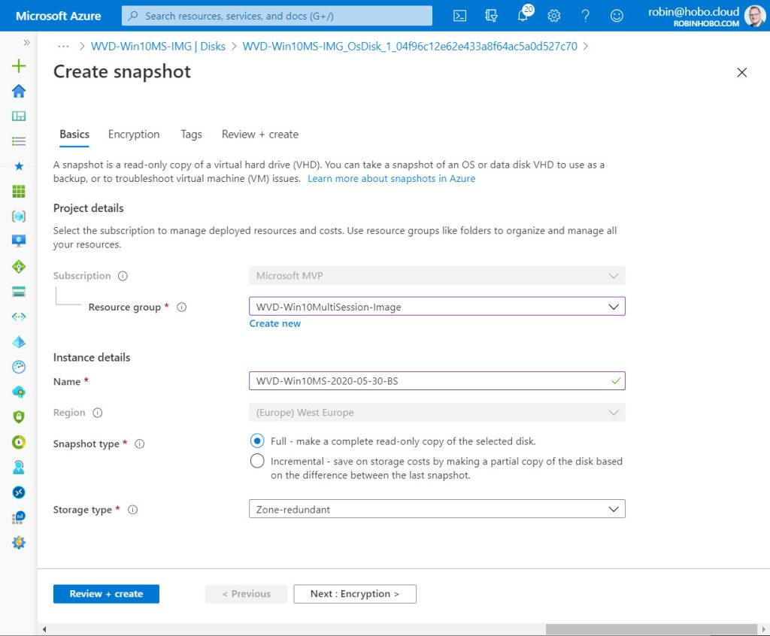](https://robinhobo.com/wp-content/uploads/2020/06/How-to-manage-and-deploy-custom-images-including-versioning-with-the-Azure-Shared-Image-Gallery-SIG-011.jpg)](https://robinhobo.com/wp-content/uploads/2020/06/How-to-manage-and-deploy-custom-images-including-versioning-with-the-Azure-Shared-Image-Gallery-SIG-011.jpg)

Select the in step 1 created **Resource group** and give the **Snapshot**name. If you are plan to create multiple versions like I do, it’s good to think about a good name convention. Also we make a Snapshot before Sysprep and a Capture after Sysprep (in the next step). Therefor I apply the following name convention:

**WVD-Win10MS-<Year>-<Month>-<Day>-BS**

**BS = Before Sysprep** in this case so I know this version is before I have run Sysprep and can be used for the next update.

Click **Review + create**

[[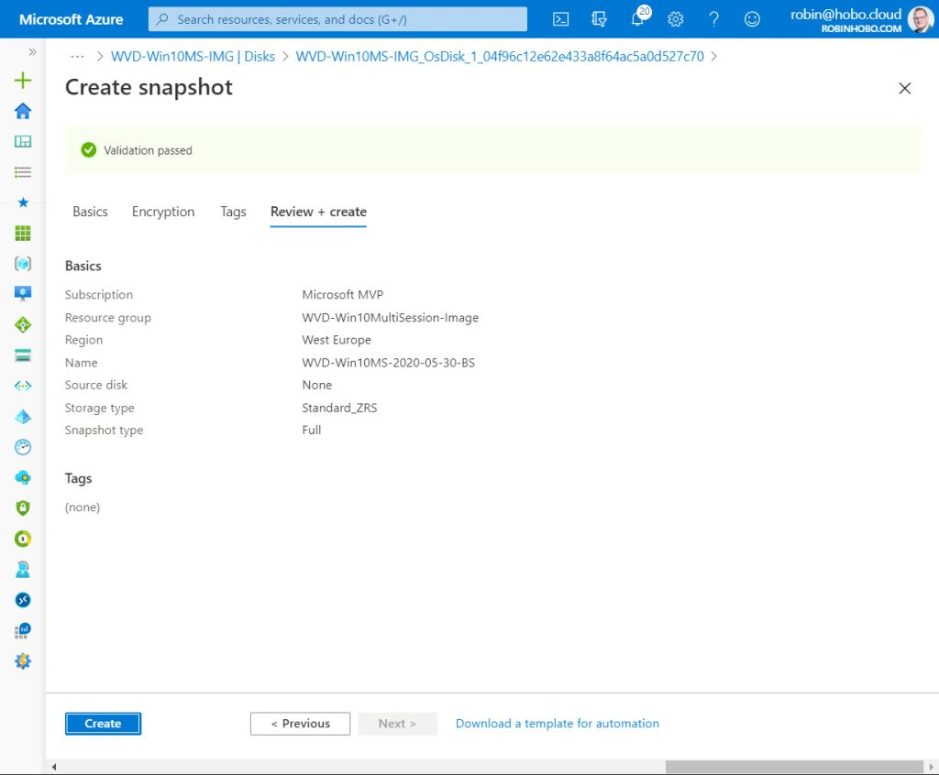](https://robinhobo.com/wp-content/uploads/2020/06/How-to-manage-and-deploy-custom-images-including-versioning-with-the-Azure-Shared-Image-Gallery-SIG-012.jpg)](https://robinhobo.com/wp-content/uploads/2020/06/How-to-manage-and-deploy-custom-images-including-versioning-with-the-Azure-Shared-Image-Gallery-SIG-012.jpg)

Click **Create**

#### **Step 3 : Creating a Virtual Machine Capture**

After creating the Disk Snapshot, start the Virtual Machine back up again.

[[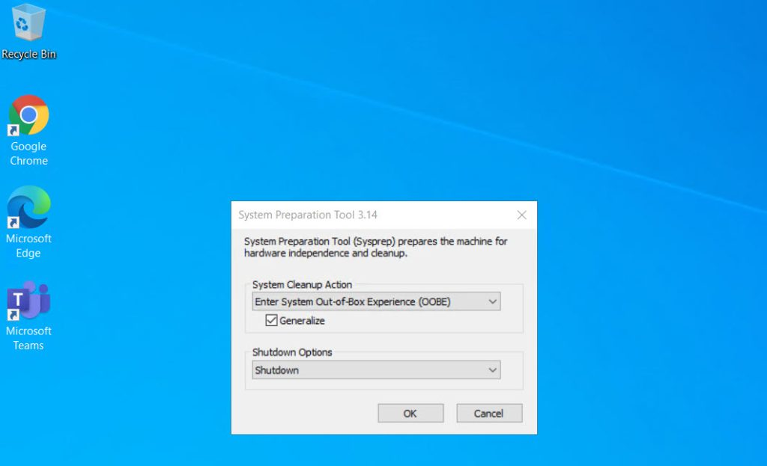](https://robinhobo.com/wp-content/uploads/2020/06/How-to-manage-and-deploy-custom-images-including-versioning-with-the-Azure-Shared-Image-Gallery-SIG-013.jpg)](https://robinhobo.com/wp-content/uploads/2020/06/How-to-manage-and-deploy-custom-images-including-versioning-with-the-Azure-Shared-Image-Gallery-SIG-013.jpg)

Connect to the Virtual Machine and run Sysprep. (C:\Windows\System32\Sysprep\sysprep.exe). Make sure to select **Generalize** and to set the **Shutdown Option**to **Shutdown**

Click **OK**

[[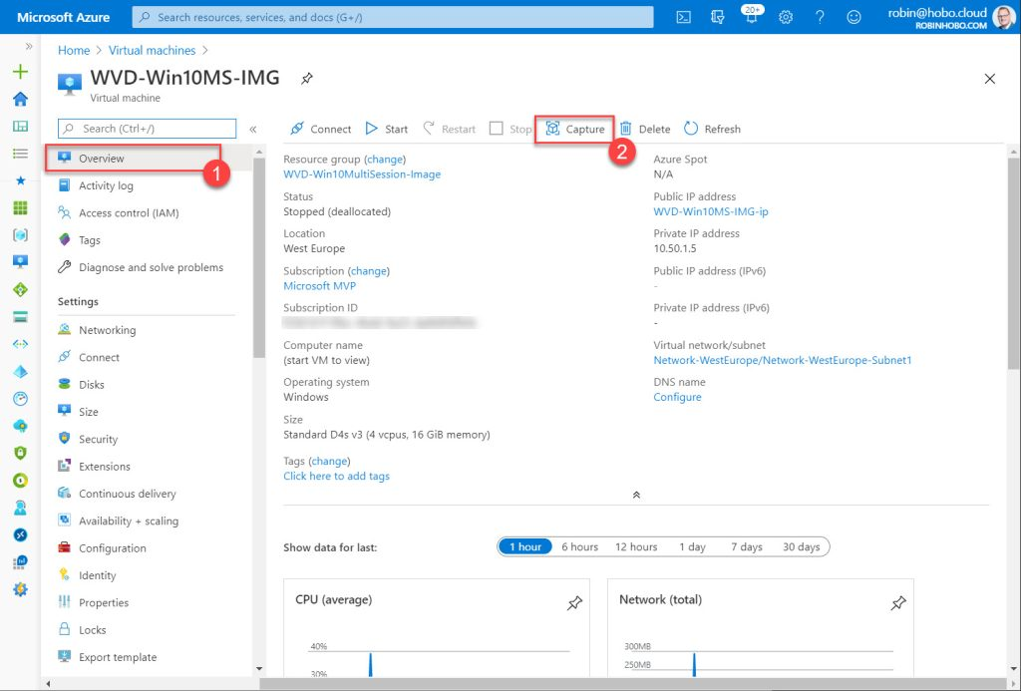](https://robinhobo.com/wp-content/uploads/2020/06/How-to-manage-and-deploy-custom-images-including-versioning-with-the-Azure-Shared-Image-Gallery-SIG-014.jpg)](https://robinhobo.com/wp-content/uploads/2020/06/How-to-manage-and-deploy-custom-images-including-versioning-with-the-Azure-Shared-Image-Gallery-SIG-014.jpg)

After the Virtual Machine has been turned off. De-allocated the Virtual Machine (select it in the Azure Portal and click **Stop**). After the Virtual Machine has the de-allocated status, go the **Overview** blade, and click **Capture**

[[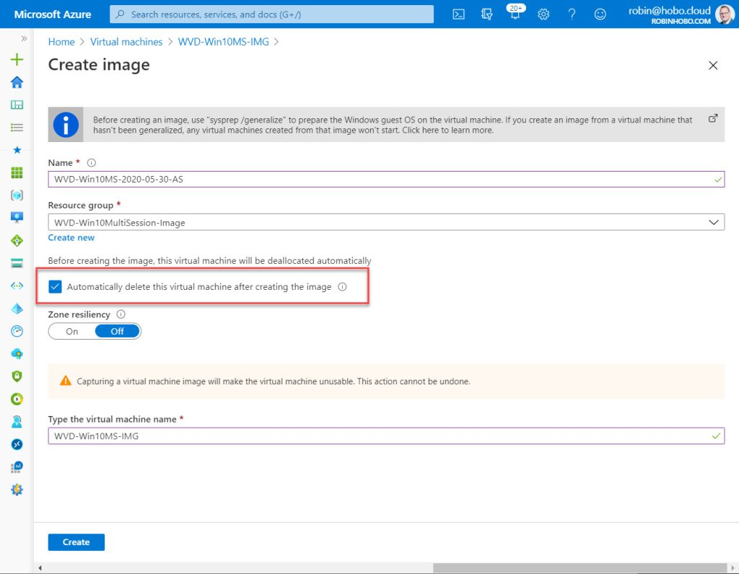](https://robinhobo.com/wp-content/uploads/2020/06/How-to-manage-and-deploy-custom-images-including-versioning-with-the-Azure-Shared-Image-Gallery-SIG-015.jpg)](https://robinhobo.com/wp-content/uploads/2020/06/How-to-manage-and-deploy-custom-images-including-versioning-with-the-Azure-Shared-Image-Gallery-SIG-015.jpg)

Give this Capture / Image a name. In this case I will give it a name with the following name convention:

**WVD-Win10MS-<Year>-<Month>-<Day>-AS**

**AS = After Sysprep** in this case. This so I know this version is after I have run Sysprep and I can use it for image deployment.

Select **Automatically delete this virtual machine after creating the image**. Type the virtual machine name and click **Create**

#### **Step 4 : Create a Shared Image Gallery (SIG)**

Before we can upload the custom image, we need to create a Shared Image Gallery (SIG) first. In the Azure search bar, search for **Shared Image Gallery** and open it.

[[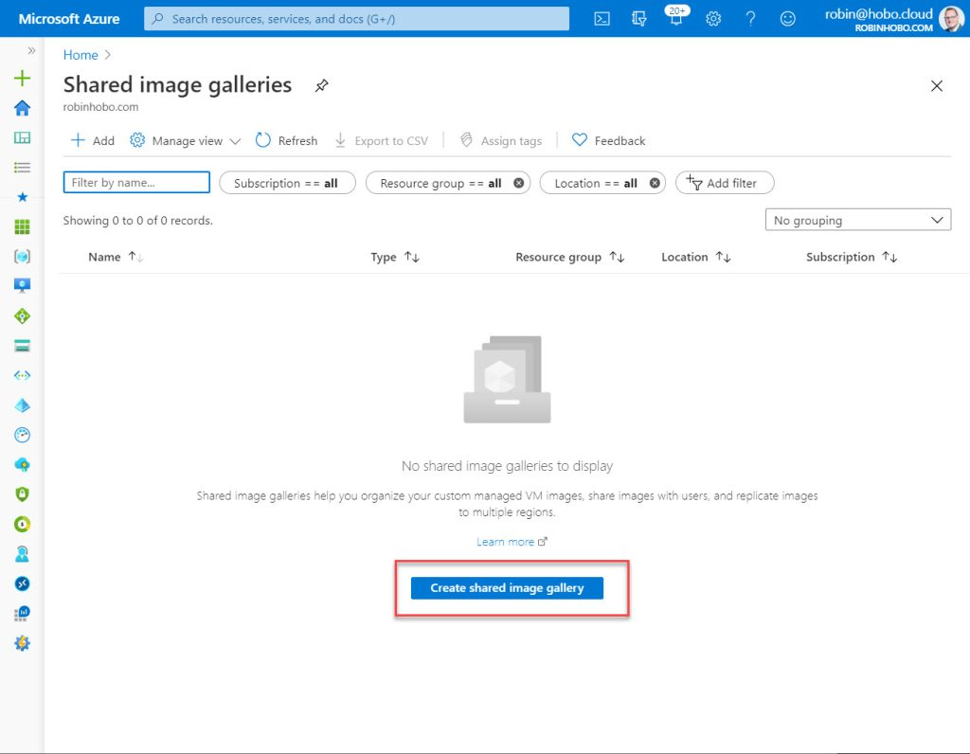](https://robinhobo.com/wp-content/uploads/2020/06/How-to-manage-and-deploy-custom-images-including-versioning-with-the-Azure-Shared-Image-Gallery-SIG-016.jpg)](https://robinhobo.com/wp-content/uploads/2020/06/How-to-manage-and-deploy-custom-images-including-versioning-with-the-Azure-Shared-Image-Gallery-SIG-016.jpg)

Click **Create shared image gallery**

[[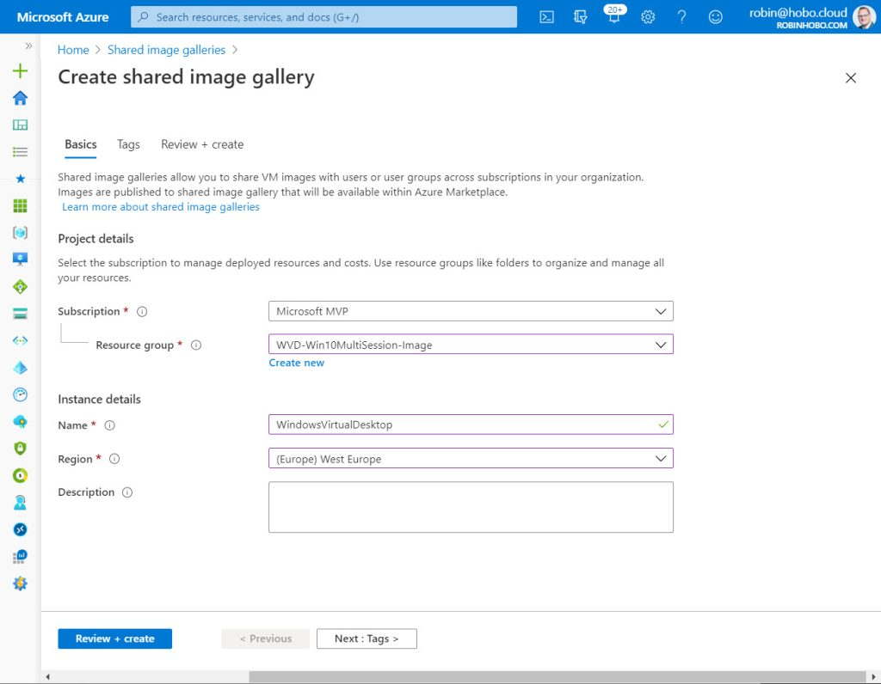](https://robinhobo.com/wp-content/uploads/2020/06/How-to-manage-and-deploy-custom-images-including-versioning-with-the-Azure-Shared-Image-Gallery-SIG-017.jpg)](https://robinhobo.com/wp-content/uploads/2020/06/How-to-manage-and-deploy-custom-images-including-versioning-with-the-Azure-Shared-Image-Gallery-SIG-017.jpg)

Select your **Subscription**and the **Resource group** you want to use. Give the Shared Image Gallery a name (in this case I will name it **WindowsVirtualDesktop**) and select a **Region**.

Click **Review + create**

[[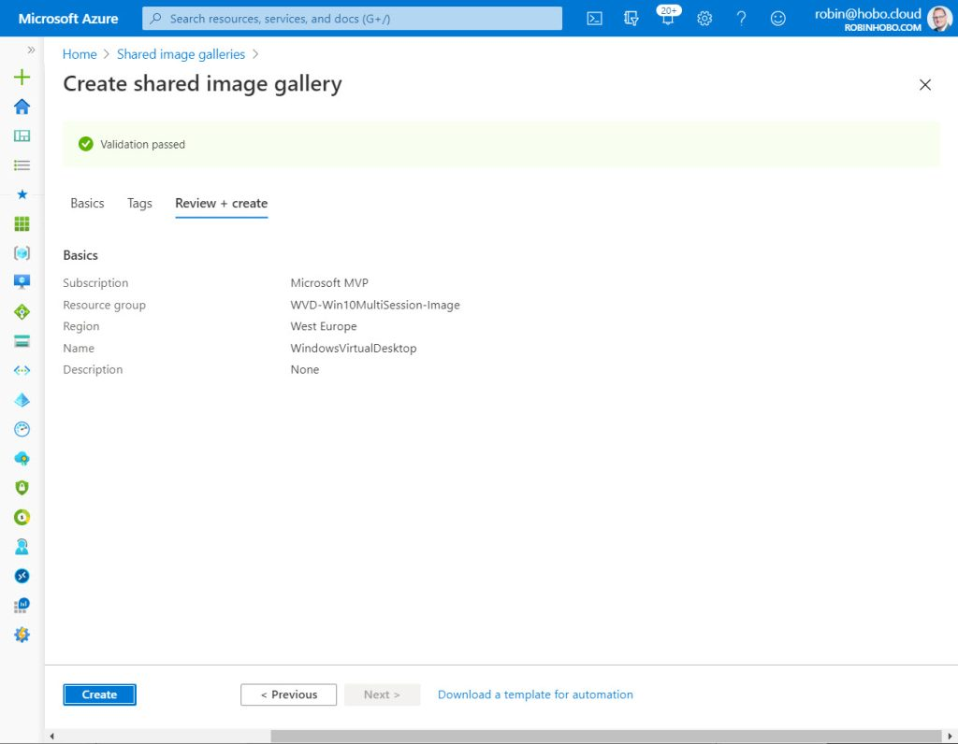](https://robinhobo.com/wp-content/uploads/2020/06/How-to-manage-and-deploy-custom-images-including-versioning-with-the-Azure-Shared-Image-Gallery-SIG-018.jpg)](https://robinhobo.com/wp-content/uploads/2020/06/How-to-manage-and-deploy-custom-images-including-versioning-with-the-Azure-Shared-Image-Gallery-SIG-018.jpg)

Click **Create**

#### **Step 5 : Add an image to the Shared Image Gallery**

[[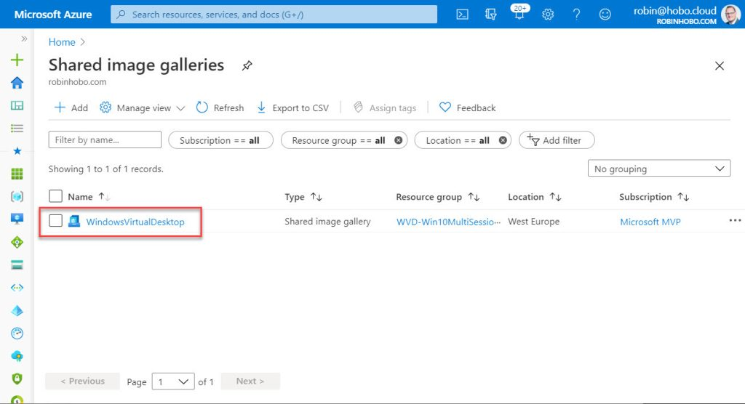](https://robinhobo.com/wp-content/uploads/2020/06/How-to-manage-and-deploy-custom-images-including-versioning-with-the-Azure-Shared-Image-Gallery-SIG-019.jpg)](https://robinhobo.com/wp-content/uploads/2020/06/How-to-manage-and-deploy-custom-images-including-versioning-with-the-Azure-Shared-Image-Gallery-SIG-019.jpg)

Open the just created Shared image Gallery (in my case **WindowsVirtualDesktop**)

[[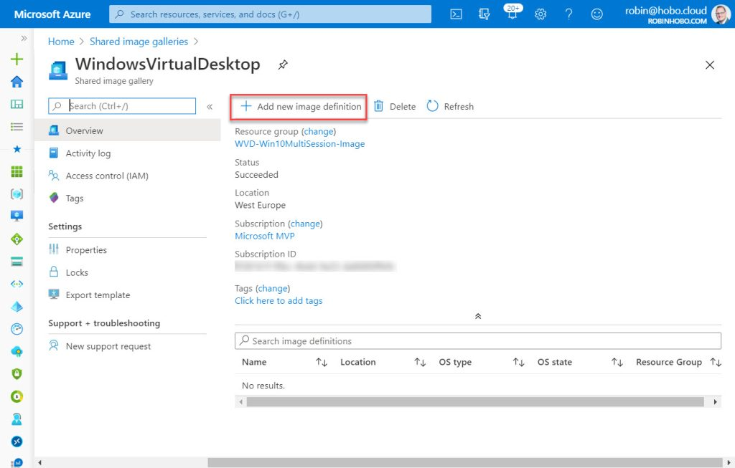](https://robinhobo.com/wp-content/uploads/2020/06/How-to-manage-and-deploy-custom-images-including-versioning-with-the-Azure-Shared-Image-Gallery-SIG-020.jpg)](https://robinhobo.com/wp-content/uploads/2020/06/How-to-manage-and-deploy-custom-images-including-versioning-with-the-Azure-Shared-Image-Gallery-SIG-020.jpg)

Click **+ Add new image definition**

[[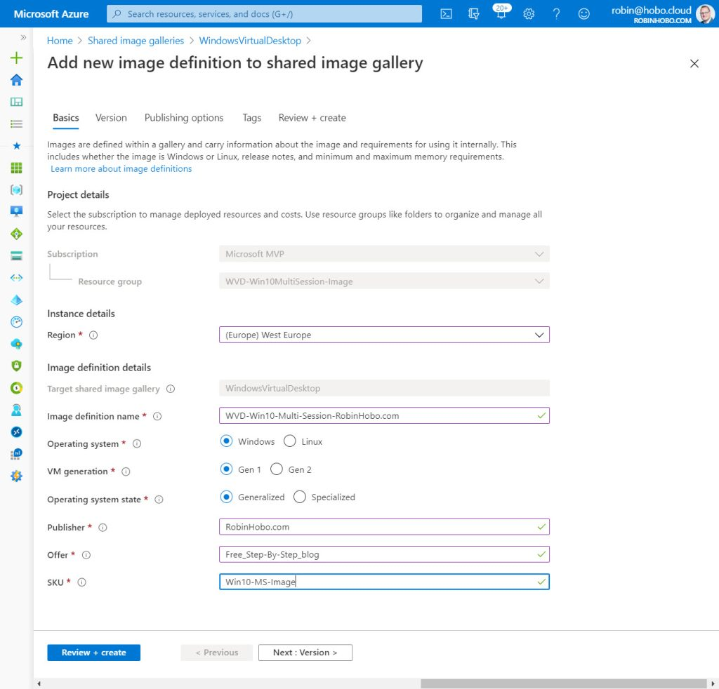](https://robinhobo.com/wp-content/uploads/2020/06/How-to-manage-and-deploy-custom-images-including-versioning-with-the-Azure-Shared-Image-Gallery-SIG-021.jpg)](https://robinhobo.com/wp-content/uploads/2020/06/How-to-manage-and-deploy-custom-images-including-versioning-with-the-Azure-Shared-Image-Gallery-SIG-021.jpg)

Select your **Region**. Give this Image definition a name, this name will be visible when deploying a Windows Virtual Desktop host pool.

Configure the following:

Operating system :  **Windows**  
VM generation : **Gen1**  
Operating system state : **Generalized**

Fill in a **Publisher**, **Offer** and a **SKU** name of choice.

Click **Next : Version**

[[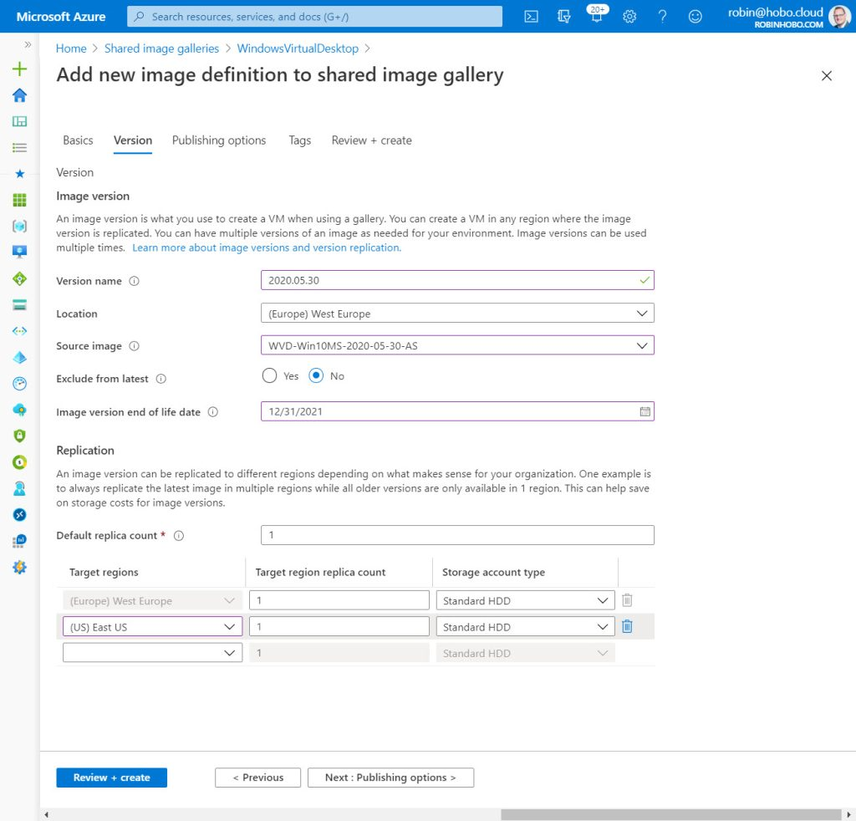](https://robinhobo.com/wp-content/uploads/2020/06/How-to-manage-and-deploy-custom-images-including-versioning-with-the-Azure-Shared-Image-Gallery-SIG-022.jpg)](https://robinhobo.com/wp-content/uploads/2020/06/How-to-manage-and-deploy-custom-images-including-versioning-with-the-Azure-Shared-Image-Gallery-SIG-022.jpg)

Fill in a Version name, this must be in the x.x.x format. Of course, you can start with 1.0.0, but you can also use a date like I do. In this case my version is: 2020.05.30 (next version needs to be higher of course).

Set **Exclude from latest**to **No**. Fill in an **Image version end of life date** and the regions you want to make this image available. I will deploy VMs with this image to the **West Europe**and **East US** so I select both locations.

Click **Review + create**

[[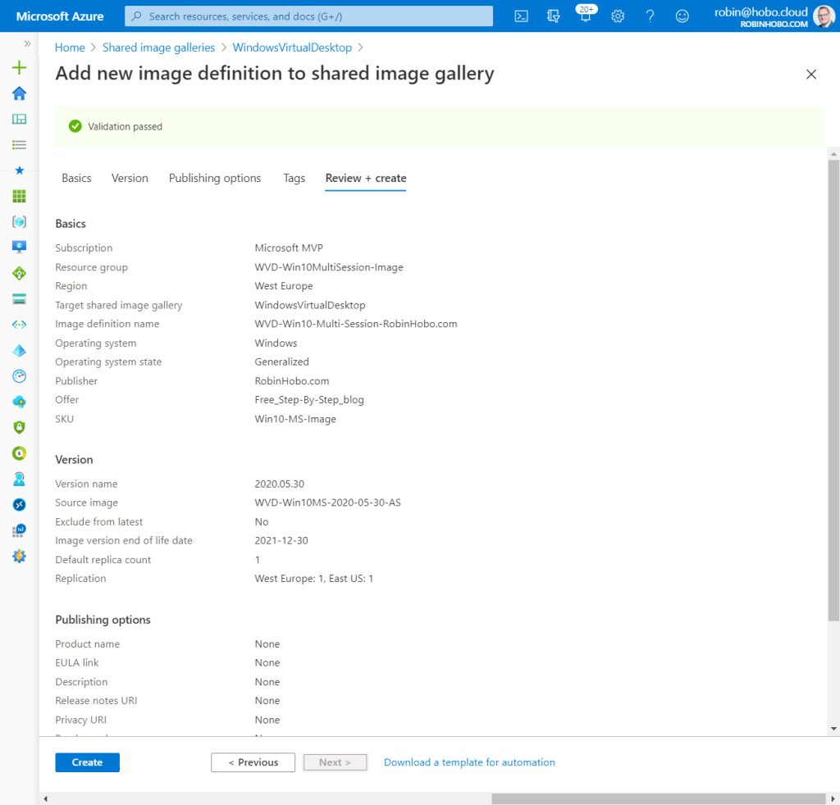](https://robinhobo.com/wp-content/uploads/2020/06/How-to-manage-and-deploy-custom-images-including-versioning-with-the-Azure-Shared-Image-Gallery-SIG-023.jpg)](https://robinhobo.com/wp-content/uploads/2020/06/How-to-manage-and-deploy-custom-images-including-versioning-with-the-Azure-Shared-Image-Gallery-SIG-023.jpg)

Click **Create**

#### **Step 6 : Deploy a Windows Virtual Desktop Host pool with the custom image**

Within the Azure portal, go the **Windows Virtual Desktop**

[[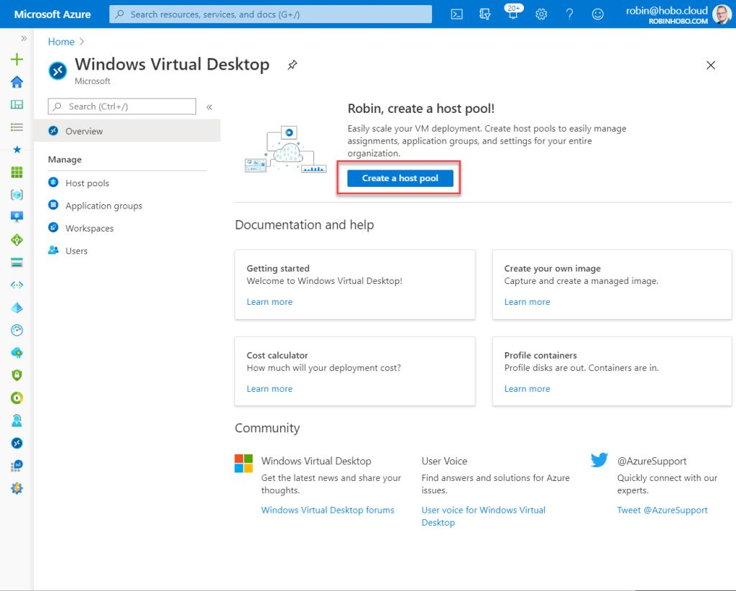](https://robinhobo.com/wp-content/uploads/2020/06/How-to-manage-and-deploy-custom-images-including-versioning-with-the-Azure-Shared-Image-Gallery-SIG-024.jpg)](https://robinhobo.com/wp-content/uploads/2020/06/How-to-manage-and-deploy-custom-images-including-versioning-with-the-Azure-Shared-Image-Gallery-SIG-024.jpg)

Click **Create a host pool**

[[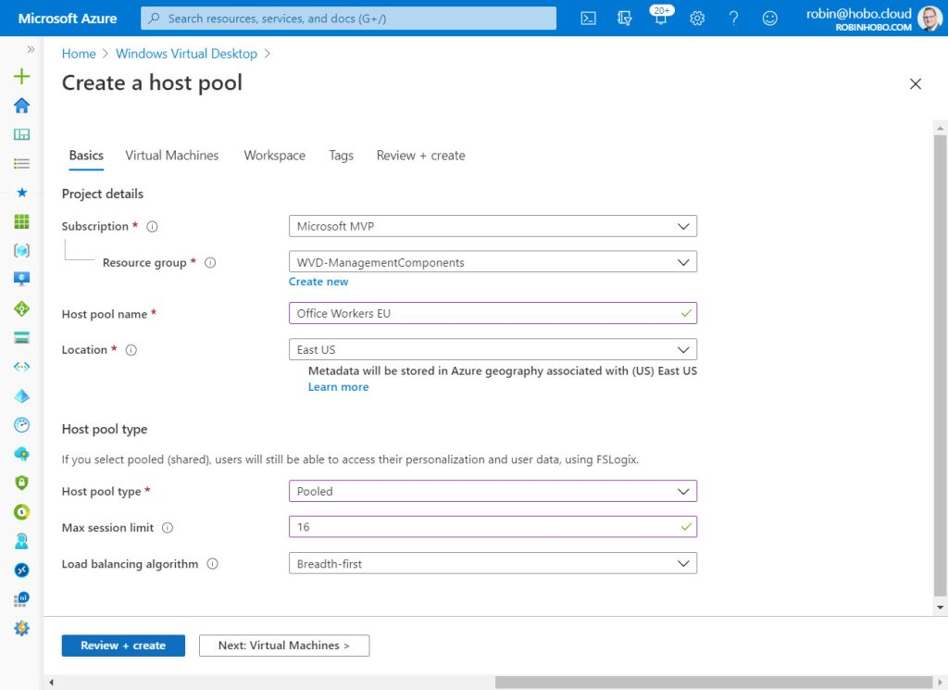](https://robinhobo.com/wp-content/uploads/2020/06/How-to-manage-and-deploy-custom-images-including-versioning-with-the-Azure-Shared-Image-Gallery-SIG-025.jpg)](https://robinhobo.com/wp-content/uploads/2020/06/How-to-manage-and-deploy-custom-images-including-versioning-with-the-Azure-Shared-Image-Gallery-SIG-025.jpg)

Select your **Subscription**and **Resource group**. Give the **Host pool** a name and select the **Location**. Select the **Host pool type**, the **Max session limit** and the **Load balancing algorithm**. Click **Next : Virtual Machines**

[[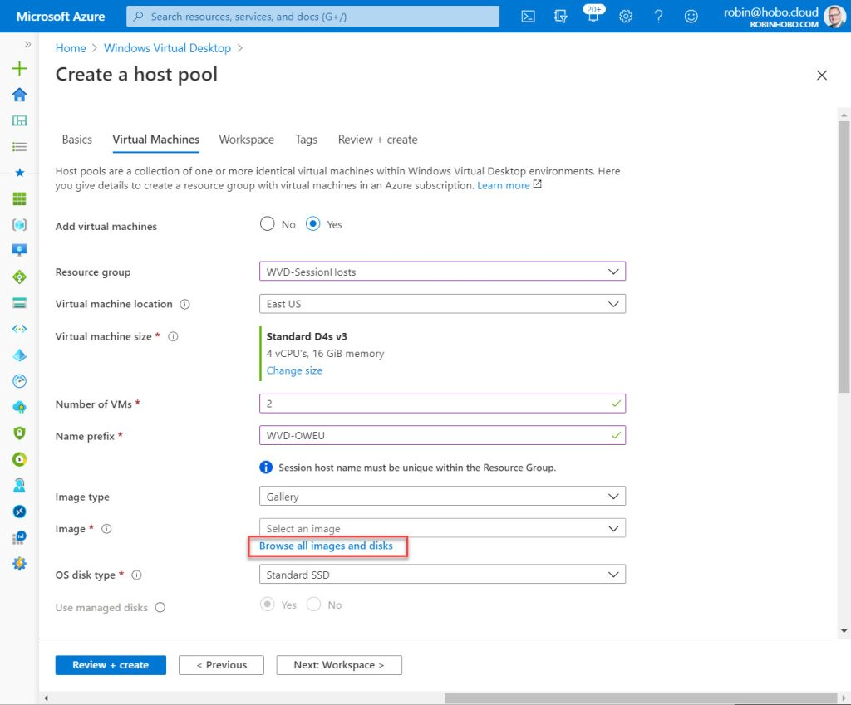](https://robinhobo.com/wp-content/uploads/2020/06/How-to-manage-and-deploy-custom-images-including-versioning-with-the-Azure-Shared-Image-Gallery-SIG-026.jpg)](https://robinhobo.com/wp-content/uploads/2020/06/How-to-manage-and-deploy-custom-images-including-versioning-with-the-Azure-Shared-Image-Gallery-SIG-026.jpg)

Select the **Resource group** for the Session Host servers and the **Virtual machine location**. Fill in the **Number of VMs** you want to create in this Host pool and enter a **Name prefix** name.

For the **Image type**, select **Gallery**, and click **Browse all images and disks**

[[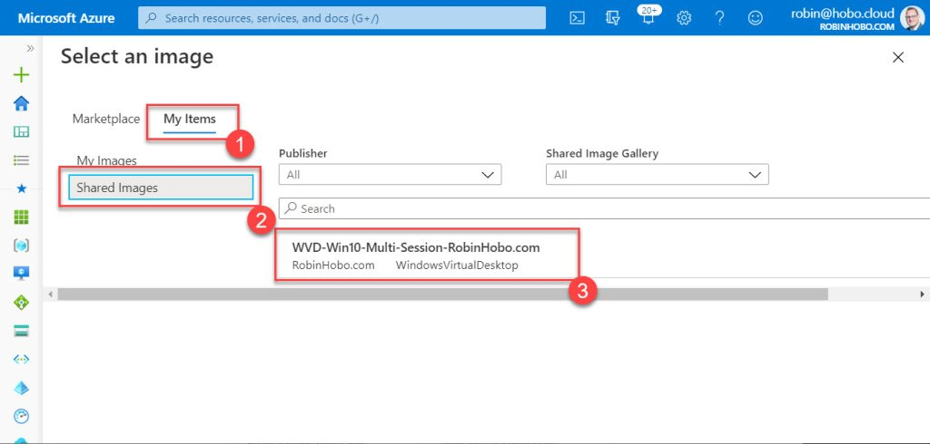](https://robinhobo.com/wp-content/uploads/2020/06/How-to-manage-and-deploy-custom-images-including-versioning-with-the-Azure-Shared-Image-Gallery-SIG-027.jpg)](https://robinhobo.com/wp-content/uploads/2020/06/How-to-manage-and-deploy-custom-images-including-versioning-with-the-Azure-Shared-Image-Gallery-SIG-027.jpg)

Click **My Items**, select **Shared Images** and click the image created in the previous step.

[[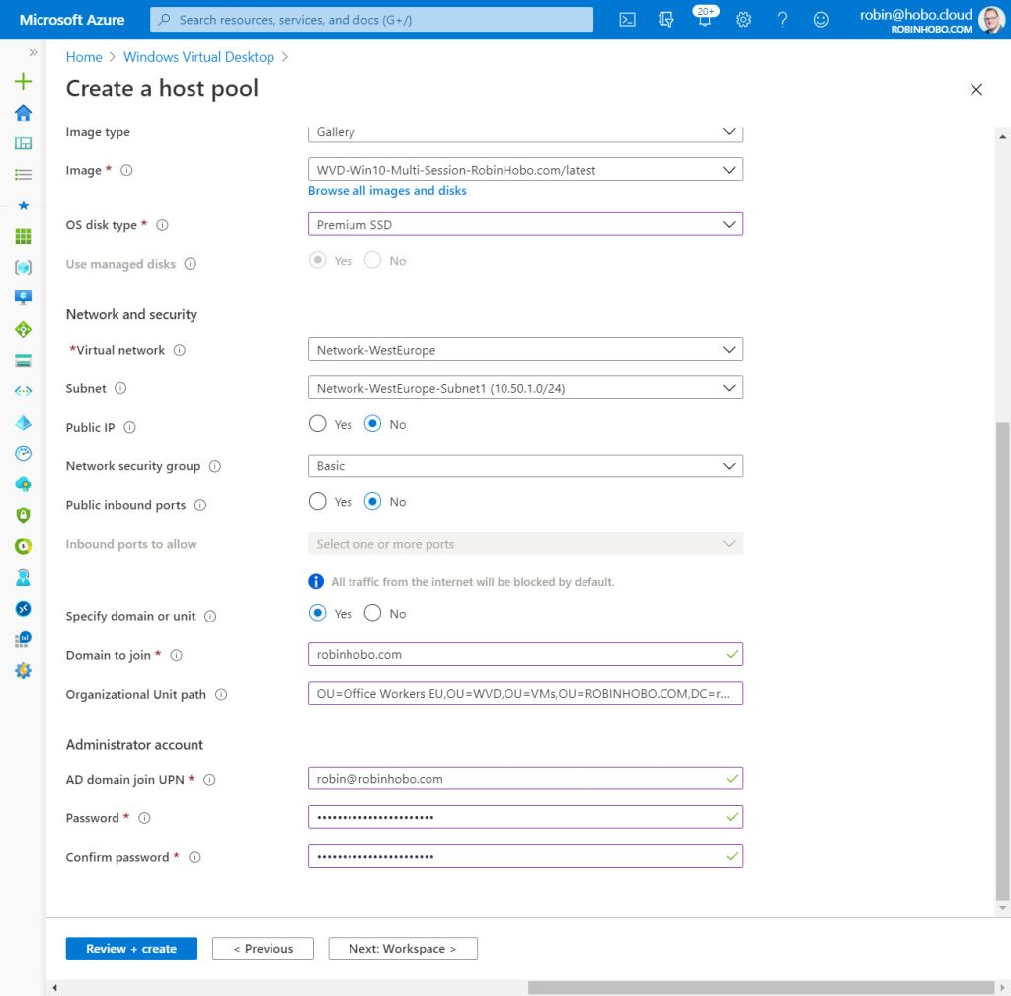](https://robinhobo.com/wp-content/uploads/2020/06/How-to-manage-and-deploy-custom-images-including-versioning-with-the-Azure-Shared-Image-Gallery-SIG-028.jpg)](https://robinhobo.com/wp-content/uploads/2020/06/How-to-manage-and-deploy-custom-images-including-versioning-with-the-Azure-Shared-Image-Gallery-SIG-028.jpg)

Select the **OS disk type**and configure the network settings. Click **Next: Workspace**

[[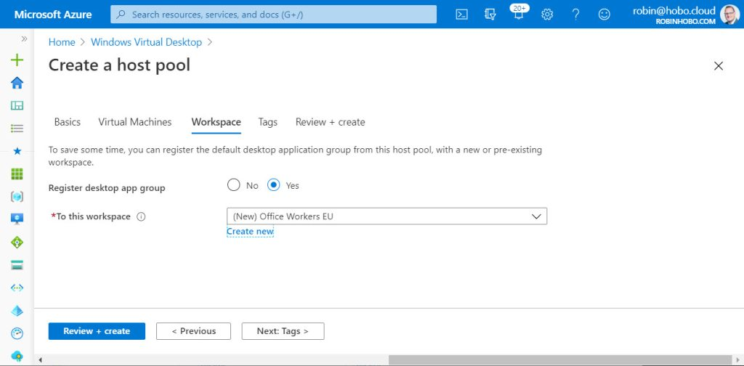](https://robinhobo.com/wp-content/uploads/2020/06/How-to-manage-and-deploy-custom-images-including-versioning-with-the-Azure-Shared-Image-Gallery-SIG-029.jpg)](https://robinhobo.com/wp-content/uploads/2020/06/How-to-manage-and-deploy-custom-images-including-versioning-with-the-Azure-Shared-Image-Gallery-SIG-029.jpg)

Select a **Workspace** or create a new one. Click **Review + create**

[[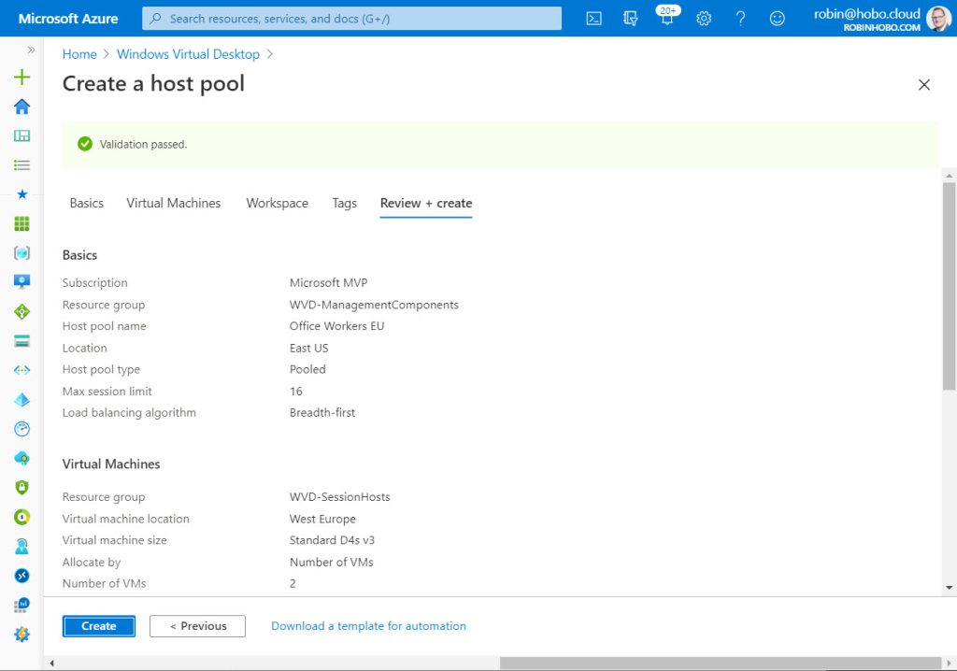](https://robinhobo.com/wp-content/uploads/2020/06/How-to-manage-and-deploy-custom-images-including-versioning-with-the-Azure-Shared-Image-Gallery-SIG-030.jpg)](https://robinhobo.com/wp-content/uploads/2020/06/How-to-manage-and-deploy-custom-images-including-versioning-with-the-Azure-Shared-Image-Gallery-SIG-030.jpg)

Click **Create**

[[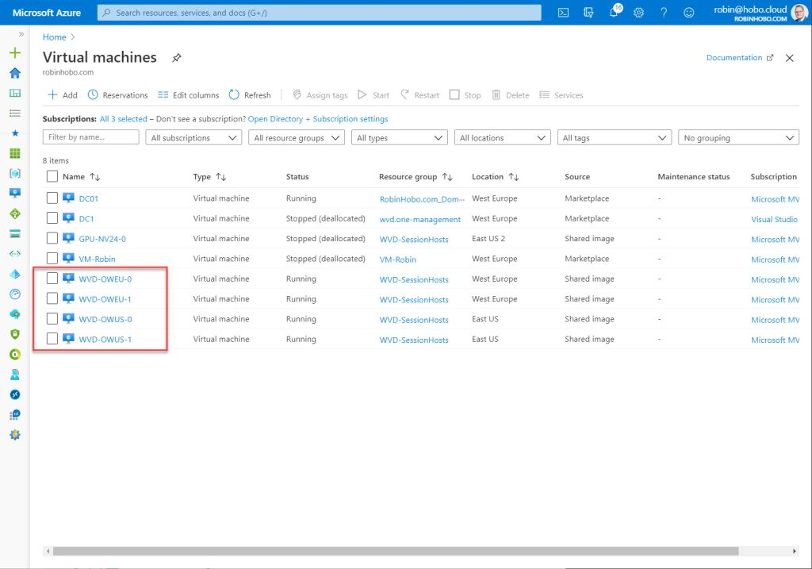](https://robinhobo.com/wp-content/uploads/2020/06/How-to-manage-and-deploy-custom-images-including-versioning-with-the-Azure-Shared-Image-Gallery-SIG-031.jpg)](https://robinhobo.com/wp-content/uploads/2020/06/How-to-manage-and-deploy-custom-images-including-versioning-with-the-Azure-Shared-Image-Gallery-SIG-031.jpg)

I repeated these steps for the **East US** region, so I have two servers in **West Europe**, and two in **East US**with the same image as source.

#### **Step 7 : Update the custom image (create Disk, new VM, Snapshot and VM Capture)**

Before we can update the custom image, we need to create a **Disk** with the **Snapshot (before Sysprep)**as sources. Next, we can create a new VM from that disk. I will show you step-by-step below.

[[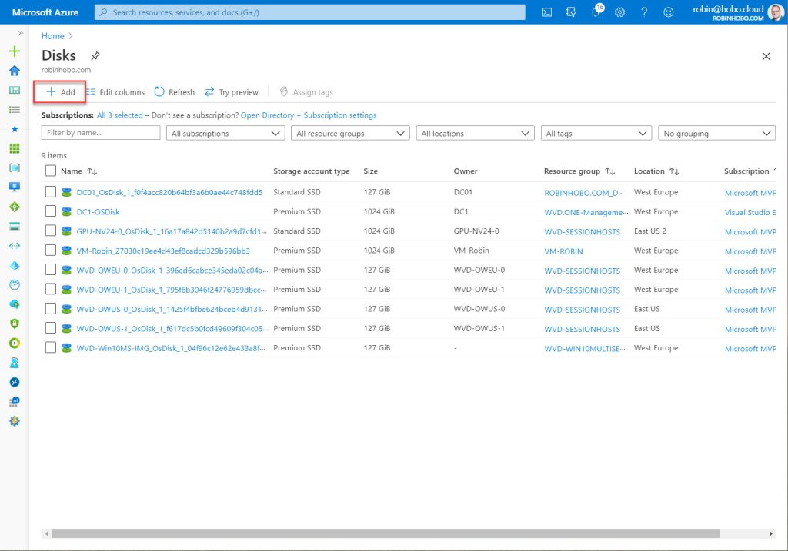](https://robinhobo.com/wp-content/uploads/2020/06/How-to-manage-and-deploy-custom-images-including-versioning-with-the-Azure-Shared-Image-Gallery-SIG-032.jpg)](https://robinhobo.com/wp-content/uploads/2020/06/How-to-manage-and-deploy-custom-images-including-versioning-with-the-Azure-Shared-Image-Gallery-SIG-032.jpg)

Within the Microsoft Azure portal, go to **Disks** and click **+ Add**

[[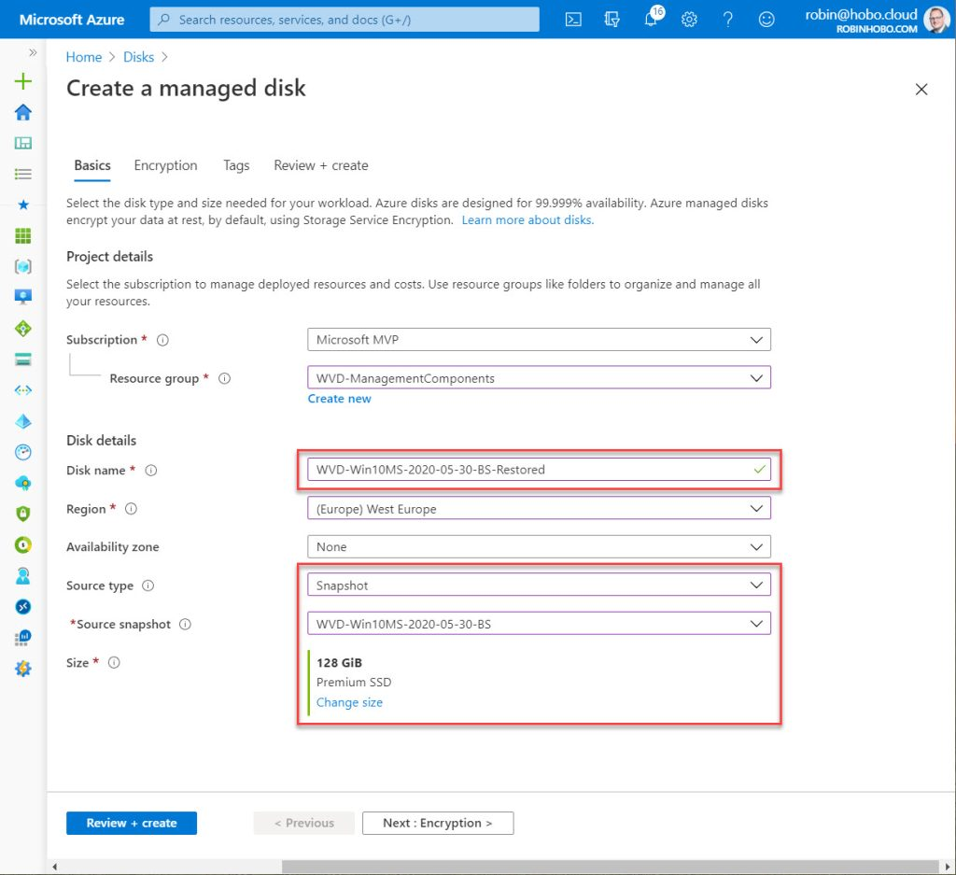](https://robinhobo.com/wp-content/uploads/2020/06/How-to-manage-and-deploy-custom-images-including-versioning-with-the-Azure-Shared-Image-Gallery-SIG-033.jpg)](https://robinhobo.com/wp-content/uploads/2020/06/How-to-manage-and-deploy-custom-images-including-versioning-with-the-Azure-Shared-Image-Gallery-SIG-033.jpg)

Select the **Subscription**and the **Resource group**. Give the Disk a name. I give it the name of the snapshot with “-Restored” at the end. So in my case “WVD-Win10MS-2020-05-30-BS-Restored”.

Select **Snapshot** as source, and select the snapshot created in previous steps. Make sure the **Disk** **Size** is correct. Click **Review + create**

[[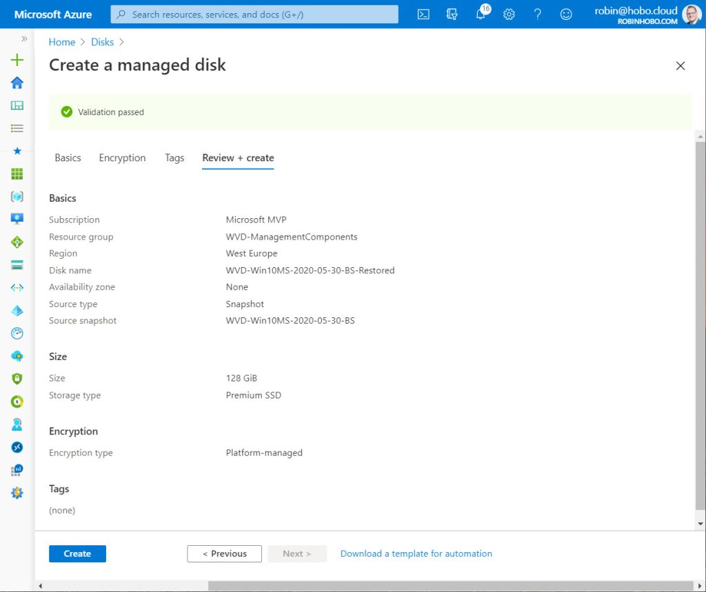](https://robinhobo.com/wp-content/uploads/2020/06/How-to-manage-and-deploy-custom-images-including-versioning-with-the-Azure-Shared-Image-Gallery-SIG-034.jpg)](https://robinhobo.com/wp-content/uploads/2020/06/How-to-manage-and-deploy-custom-images-including-versioning-with-the-Azure-Shared-Image-Gallery-SIG-034.jpg)

Click **Create**

[[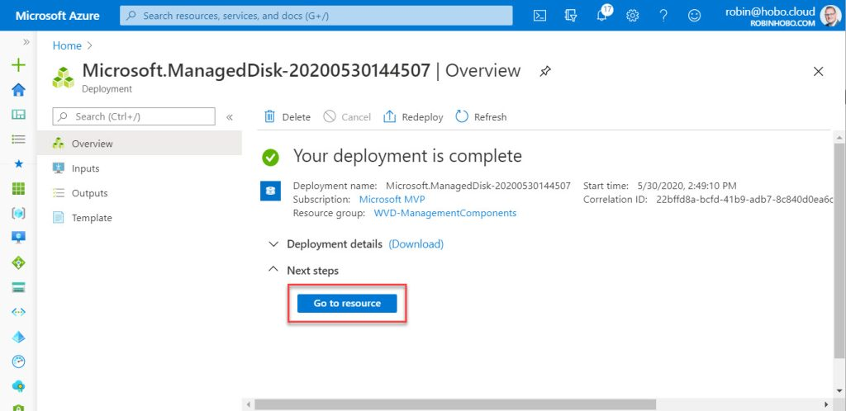](https://robinhobo.com/wp-content/uploads/2020/06/How-to-manage-and-deploy-custom-images-including-versioning-with-the-Azure-Shared-Image-Gallery-SIG-035.jpg)](https://robinhobo.com/wp-content/uploads/2020/06/How-to-manage-and-deploy-custom-images-including-versioning-with-the-Azure-Shared-Image-Gallery-SIG-035.jpg)

After the deployment is complete, click **Go to resource**

[[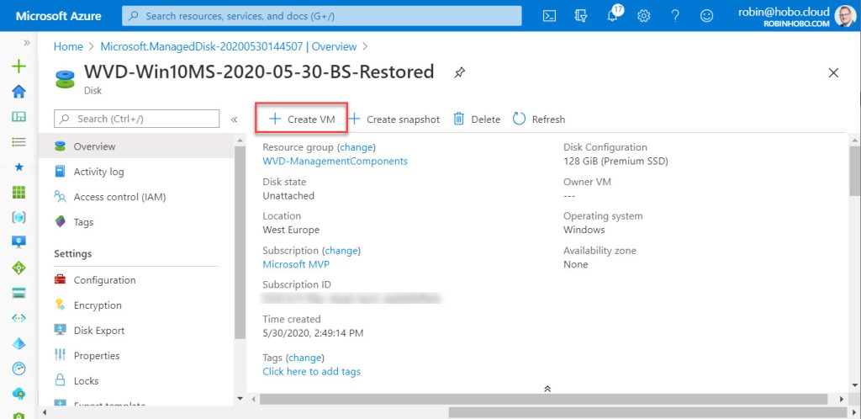](https://robinhobo.com/wp-content/uploads/2020/06/How-to-manage-and-deploy-custom-images-including-versioning-with-the-Azure-Shared-Image-Gallery-SIG-036.jpg)](https://robinhobo.com/wp-content/uploads/2020/06/How-to-manage-and-deploy-custom-images-including-versioning-with-the-Azure-Shared-Image-Gallery-SIG-036.jpg)

Click **+ Create VM**

[[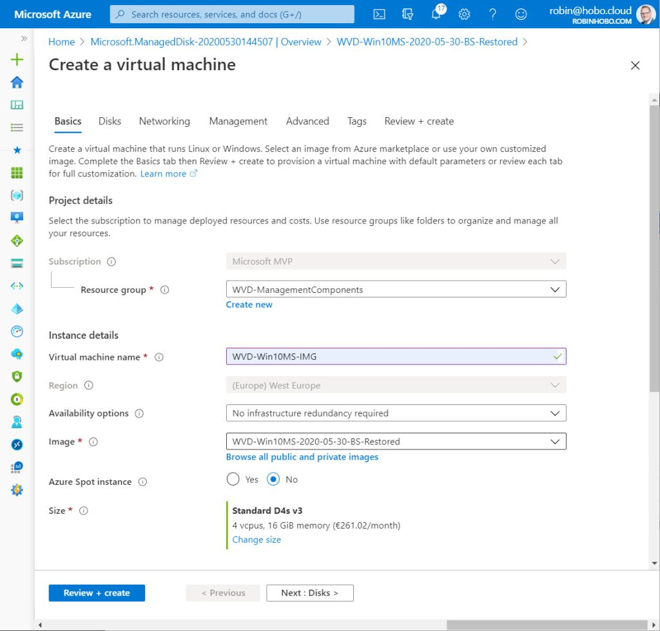](https://robinhobo.com/wp-content/uploads/2020/06/How-to-manage-and-deploy-custom-images-including-versioning-with-the-Azure-Shared-Image-Gallery-SIG-037.jpg)](https://robinhobo.com/wp-content/uploads/2020/06/How-to-manage-and-deploy-custom-images-including-versioning-with-the-Azure-Shared-Image-Gallery-SIG-037.jpg)

Select the **Resource group** of choice and give the **Virtual machine** a **name**. Make sure the correct **Image** is selected and click **Next : Disks**

[[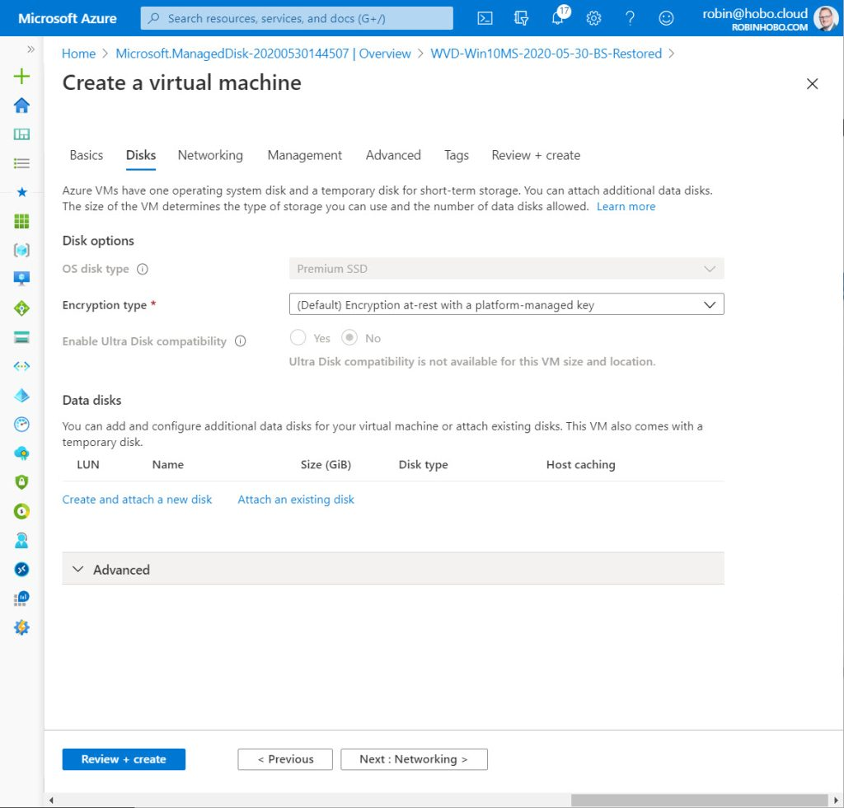](https://robinhobo.com/wp-content/uploads/2020/06/How-to-manage-and-deploy-custom-images-including-versioning-with-the-Azure-Shared-Image-Gallery-SIG-038.jpg)](https://robinhobo.com/wp-content/uploads/2020/06/How-to-manage-and-deploy-custom-images-including-versioning-with-the-Azure-Shared-Image-Gallery-SIG-038.jpg)

Click **Next: Networking**

[[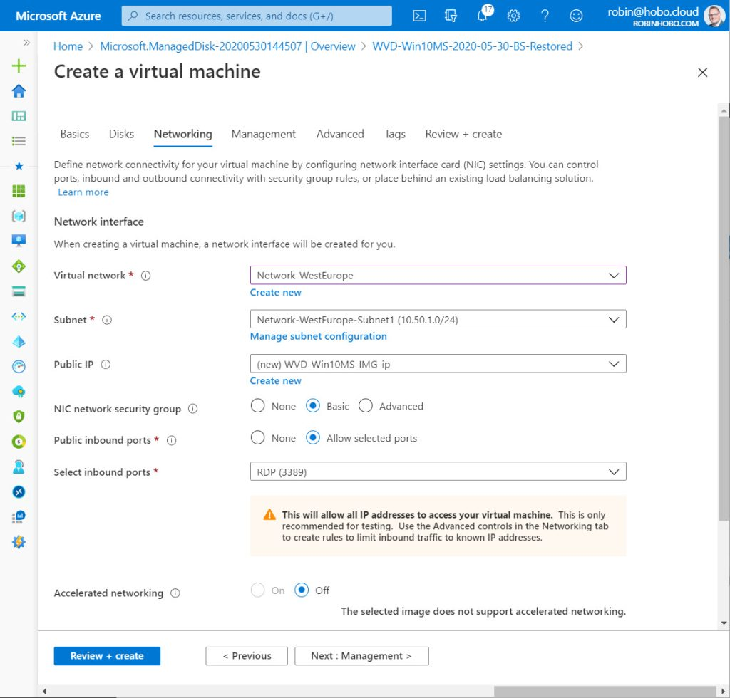](https://robinhobo.com/wp-content/uploads/2020/06/How-to-manage-and-deploy-custom-images-including-versioning-with-the-Azure-Shared-Image-Gallery-SIG-039.jpg)](https://robinhobo.com/wp-content/uploads/2020/06/How-to-manage-and-deploy-custom-images-including-versioning-with-the-Azure-Shared-Image-Gallery-SIG-039.jpg)

Configure your network settings and click **Next: Management**

[[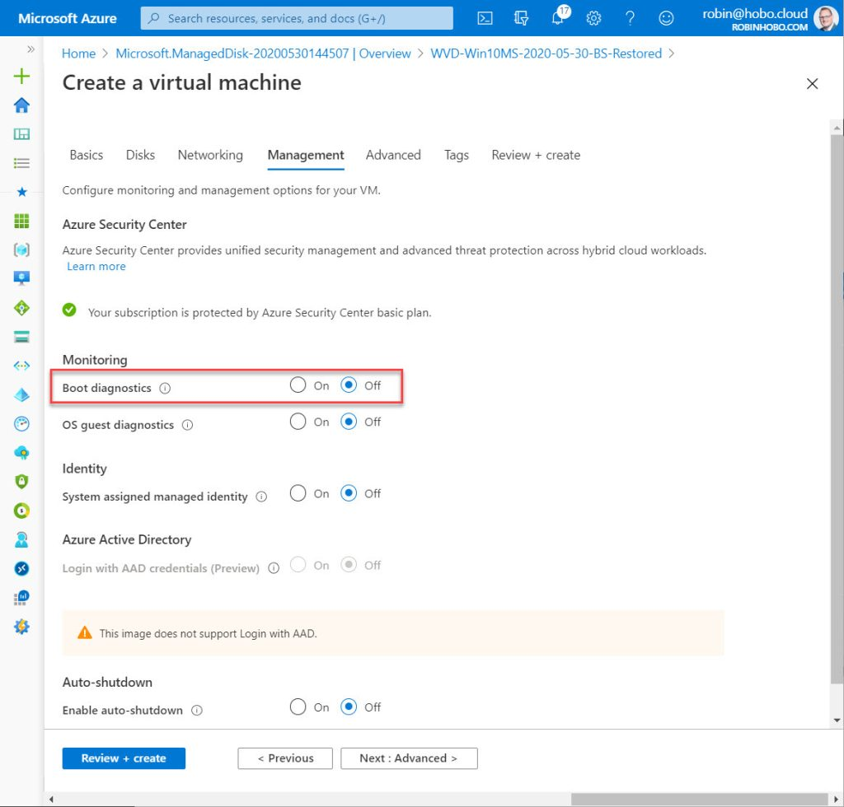](https://robinhobo.com/wp-content/uploads/2020/06/How-to-manage-and-deploy-custom-images-including-versioning-with-the-Azure-Shared-Image-Gallery-SIG-040.jpg)](https://robinhobo.com/wp-content/uploads/2020/06/How-to-manage-and-deploy-custom-images-including-versioning-with-the-Azure-Shared-Image-Gallery-SIG-040.jpg)

Set **Boot diagnostics** to off and click **Review + create**

[[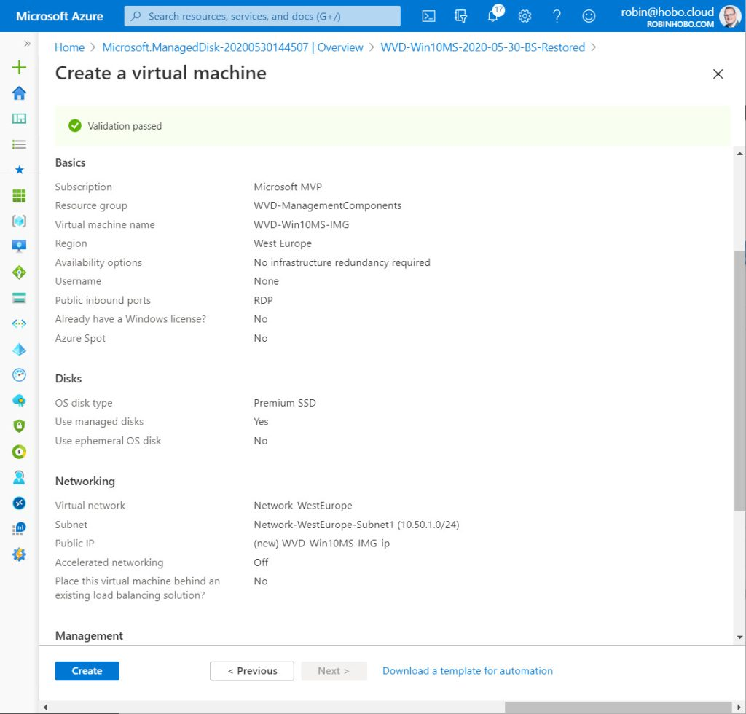](https://robinhobo.com/wp-content/uploads/2020/06/How-to-manage-and-deploy-custom-images-including-versioning-with-the-Azure-Shared-Image-Gallery-SIG-041.jpg)](https://robinhobo.com/wp-content/uploads/2020/06/How-to-manage-and-deploy-custom-images-including-versioning-with-the-Azure-Shared-Image-Gallery-SIG-041.jpg)

Click **Create**

[[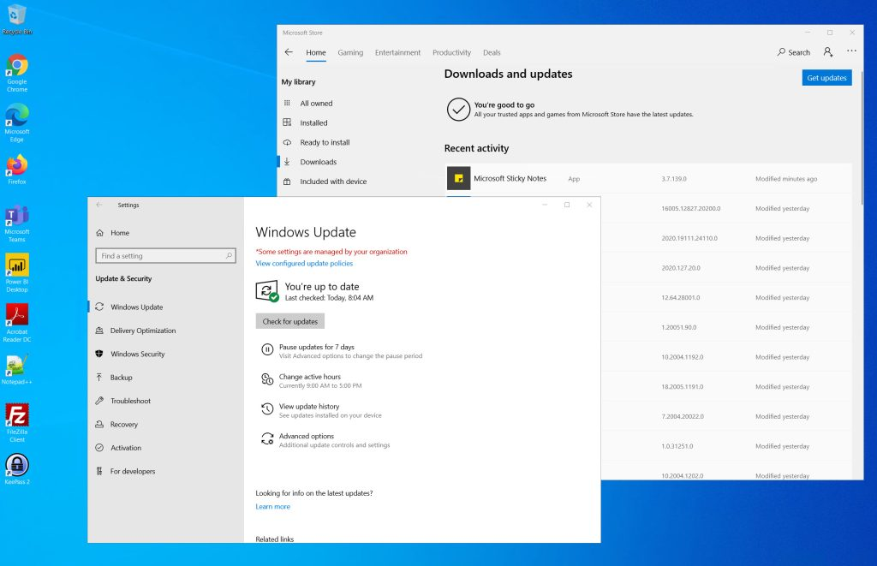](https://robinhobo.com/wp-content/uploads/2020/06/How-to-manage-and-deploy-custom-images-including-versioning-with-the-Azure-Shared-Image-Gallery-SIG-042.jpg)](https://robinhobo.com/wp-content/uploads/2020/06/How-to-manage-and-deploy-custom-images-including-versioning-with-the-Azure-Shared-Image-Gallery-SIG-042.jpg)

After the deployment is complete, login to the VM and make the required changes.

When your finished with the changes in the VM, **repeat Step 2** (Make a disk Snapshot) a**nd Step 3** (Creating a Virtual Machine Capture) of this blog (with new dates in the snapshot and image name).

#### **Step 8 : Add a version to the image in the Shared Image Gallery**

Now that we have a new image version (VM Capture) we need to add this to the current custom image in the Shared Image Gallery.

[[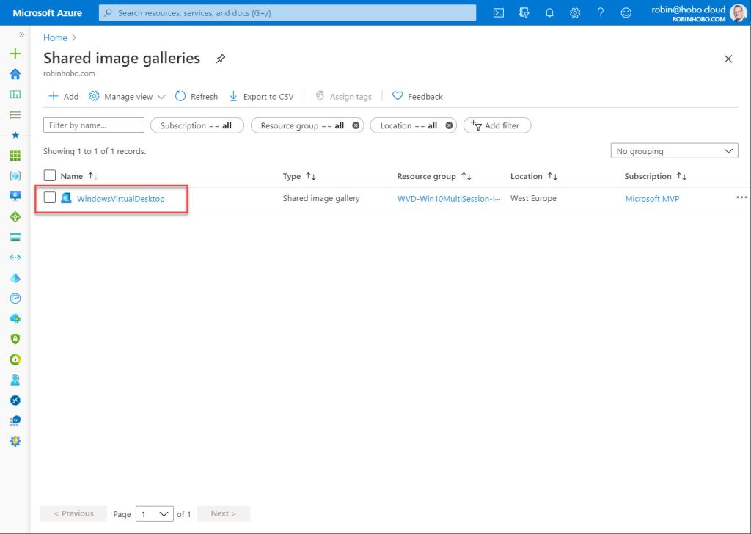](https://robinhobo.com/wp-content/uploads/2020/06/How-to-manage-and-deploy-custom-images-including-versioning-with-the-Azure-Shared-Image-Gallery-SIG-050.jpg)](https://robinhobo.com/wp-content/uploads/2020/06/How-to-manage-and-deploy-custom-images-including-versioning-with-the-Azure-Shared-Image-Gallery-SIG-050.jpg)

Go to the **Shared Image Gallery** and click the WindowsVirtualDekstop Shared image gallery.

[[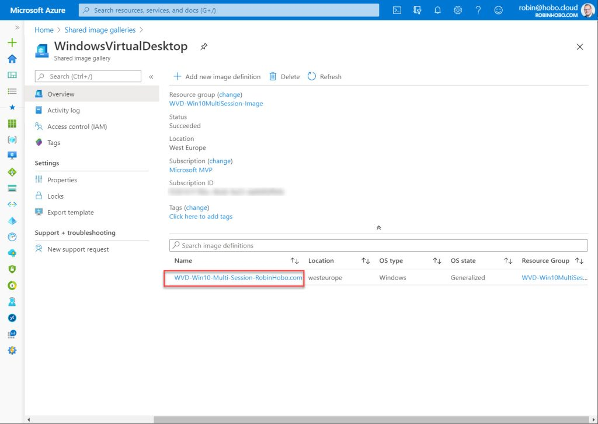](https://robinhobo.com/wp-content/uploads/2020/06/How-to-manage-and-deploy-custom-images-including-versioning-with-the-Azure-Shared-Image-Gallery-SIG-051.jpg)](https://robinhobo.com/wp-content/uploads/2020/06/How-to-manage-and-deploy-custom-images-including-versioning-with-the-Azure-Shared-Image-Gallery-SIG-051.jpg)

Click the custom image created in previous steps.

[[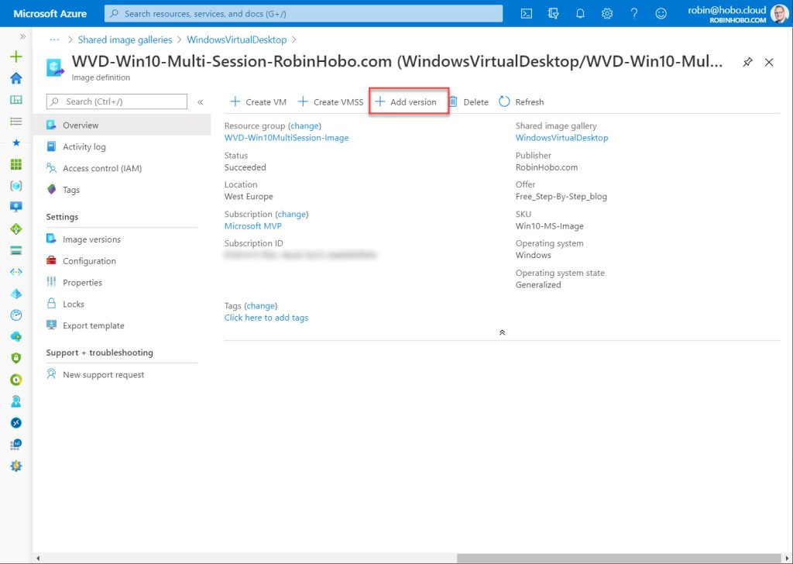](https://robinhobo.com/wp-content/uploads/2020/06/How-to-manage-and-deploy-custom-images-including-versioning-with-the-Azure-Shared-Image-Gallery-SIG-052.jpg)](https://robinhobo.com/wp-content/uploads/2020/06/How-to-manage-and-deploy-custom-images-including-versioning-with-the-Azure-Shared-Image-Gallery-SIG-052.jpg)

Click **+ Add Version**

[[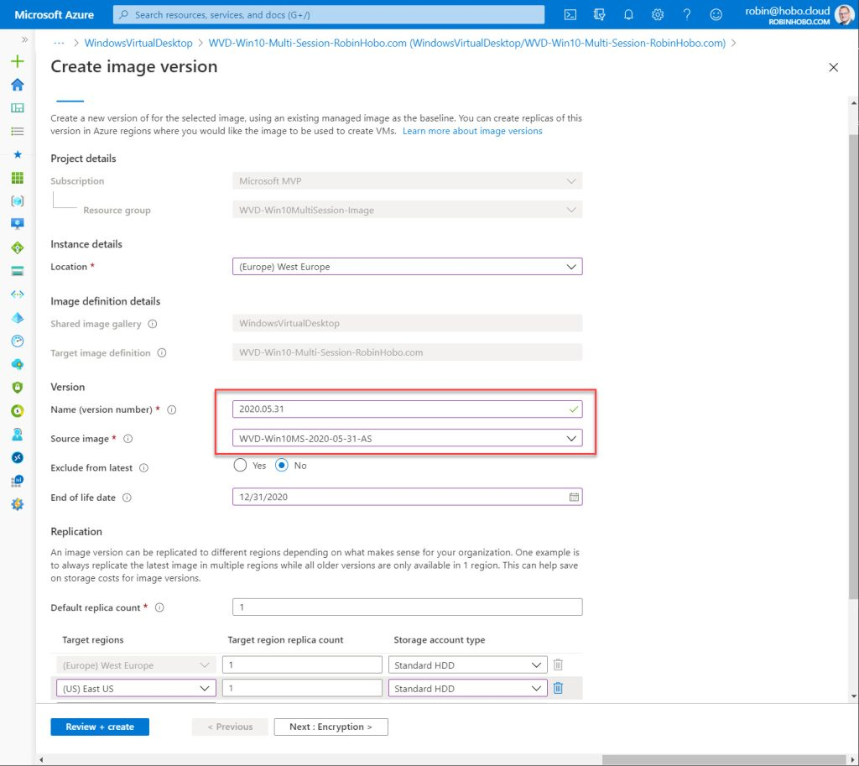](https://robinhobo.com/wp-content/uploads/2020/06/How-to-manage-and-deploy-custom-images-including-versioning-with-the-Azure-Shared-Image-Gallery-SIG-053.jpg)](https://robinhobo.com/wp-content/uploads/2020/06/How-to-manage-and-deploy-custom-images-including-versioning-with-the-Azure-Shared-Image-Gallery-SIG-053.jpg)

Fill in the **Version** (date of image in my case) and the **Source image**. Make sure **Exclude from latest**is set to **No**. Select the **Target regions** and click **Review + create**

[[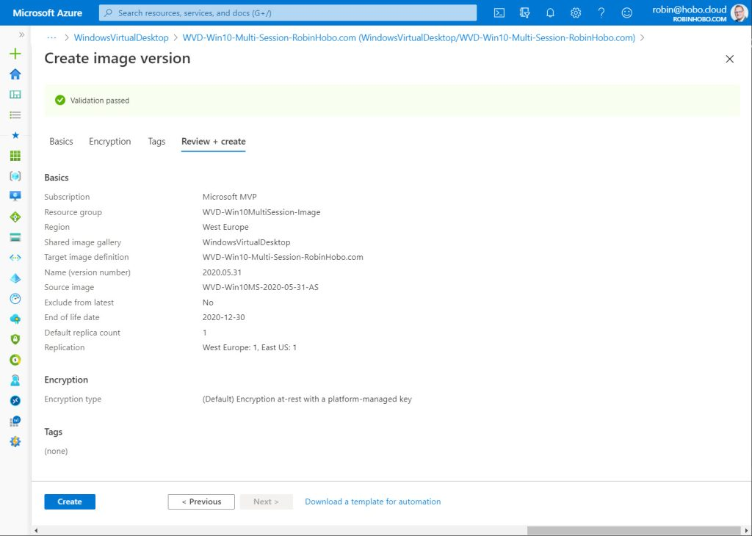](https://robinhobo.com/wp-content/uploads/2020/06/How-to-manage-and-deploy-custom-images-including-versioning-with-the-Azure-Shared-Image-Gallery-SIG-054.jpg)](https://robinhobo.com/wp-content/uploads/2020/06/How-to-manage-and-deploy-custom-images-including-versioning-with-the-Azure-Shared-Image-Gallery-SIG-054.jpg)

Click **Create**

#### **Step 9 : Update the Windows Virtual Desktop Host pool with the new image**

In this final step we are going to update the Windows Virtual Desktop Host pool with the new version of the custom image. We do this by creating new Session Host VMs and enabling Drain mode on the old (current) VMs. If for some reason the new version of the image is not working you have a fall back to these (old) servers.

But first we need to add the new servers.

[[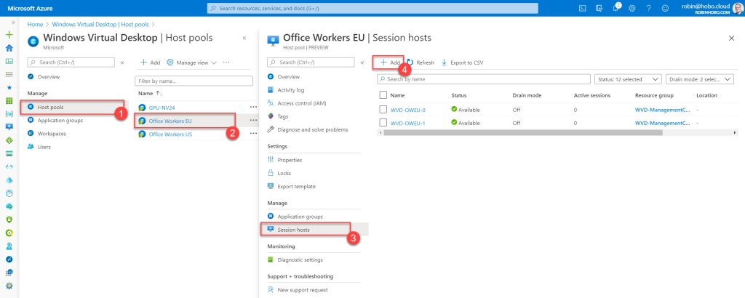](https://robinhobo.com/wp-content/uploads/2020/06/How-to-manage-and-deploy-custom-images-including-versioning-with-the-Azure-Shared-Image-Gallery-SIG-055.jpg)](https://robinhobo.com/wp-content/uploads/2020/06/How-to-manage-and-deploy-custom-images-including-versioning-with-the-Azure-Shared-Image-Gallery-SIG-055.jpg)

Within the Windows Virtual Desktop portal, navigate to **Host pools > <your host pool> > Session hosts** and click the **+ Add** button.

[[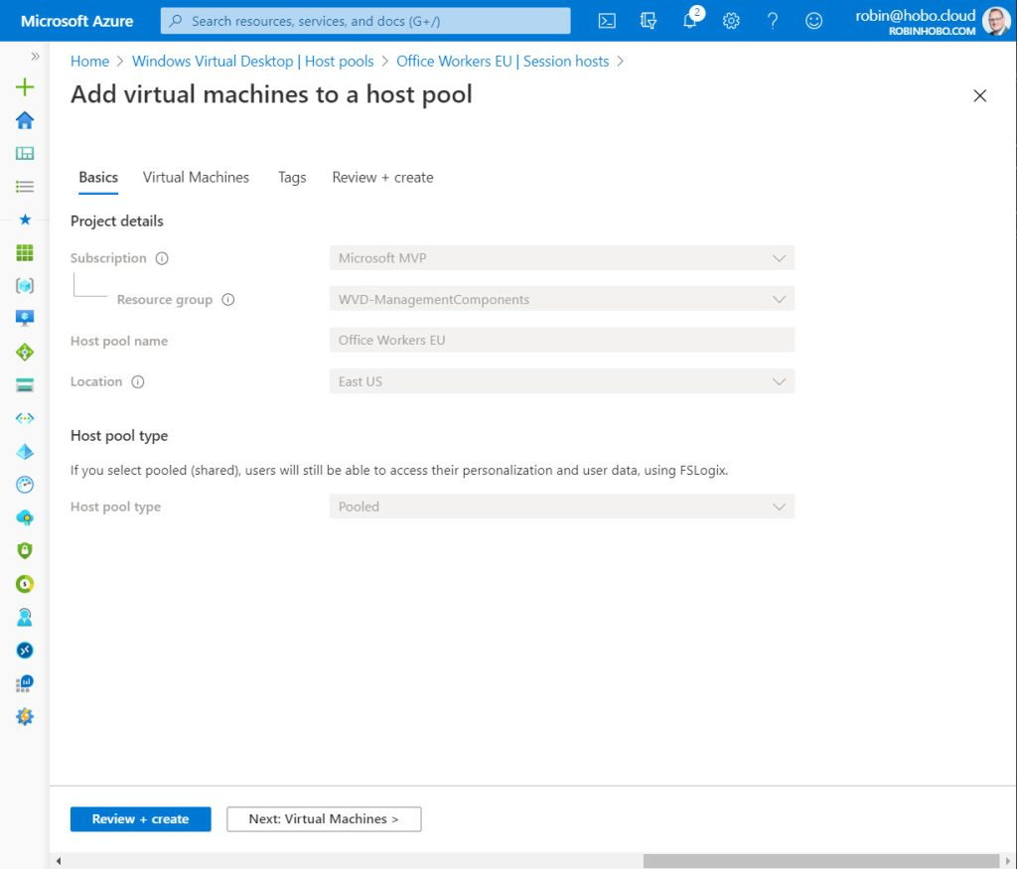](https://robinhobo.com/wp-content/uploads/2020/06/How-to-manage-and-deploy-custom-images-including-versioning-with-the-Azure-Shared-Image-Gallery-SIG-056.jpg)](https://robinhobo.com/wp-content/uploads/2020/06/How-to-manage-and-deploy-custom-images-including-versioning-with-the-Azure-Shared-Image-Gallery-SIG-056.jpg)

Click **Next: Virtual Machines**

[[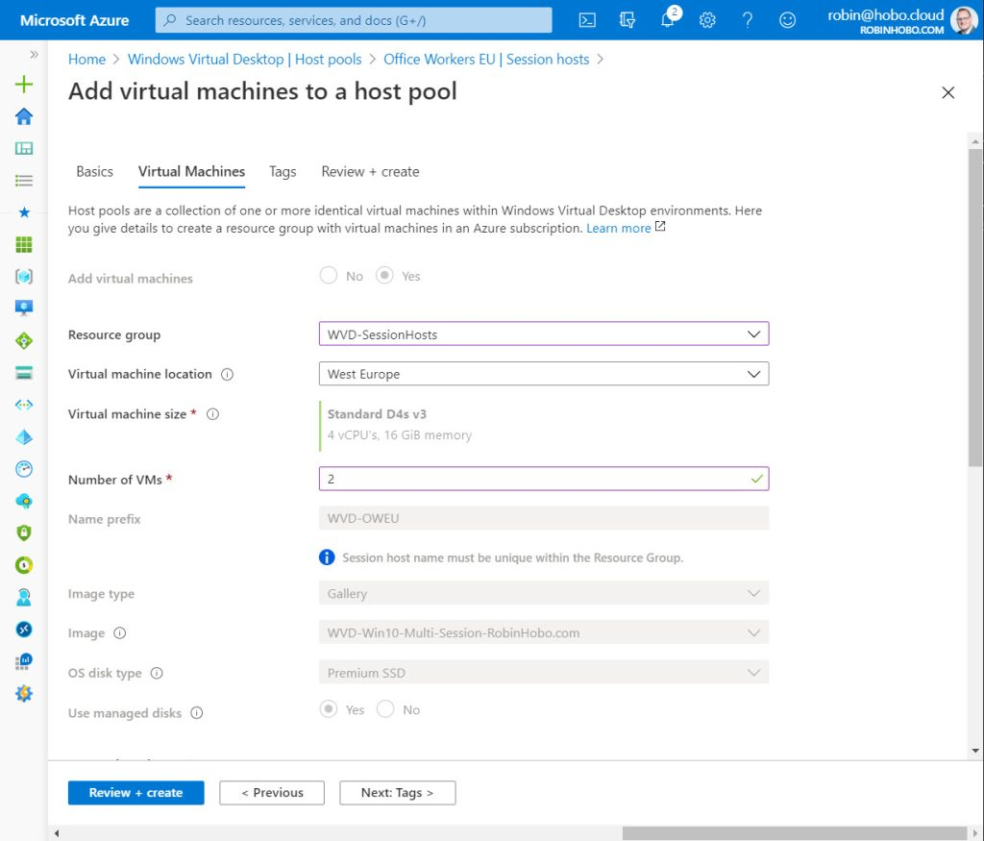](https://robinhobo.com/wp-content/uploads/2020/06/How-to-manage-and-deploy-custom-images-including-versioning-with-the-Azure-Shared-Image-Gallery-SIG-057.jpg)](https://robinhobo.com/wp-content/uploads/2020/06/How-to-manage-and-deploy-custom-images-including-versioning-with-the-Azure-Shared-Image-Gallery-SIG-057.jpg)

Select the **Resource group** and the **Virtual machine location**. Fill in the **Number of VMs** you want to add to this Host pool. Note that all other options are grayed out. **Scroll down**

[[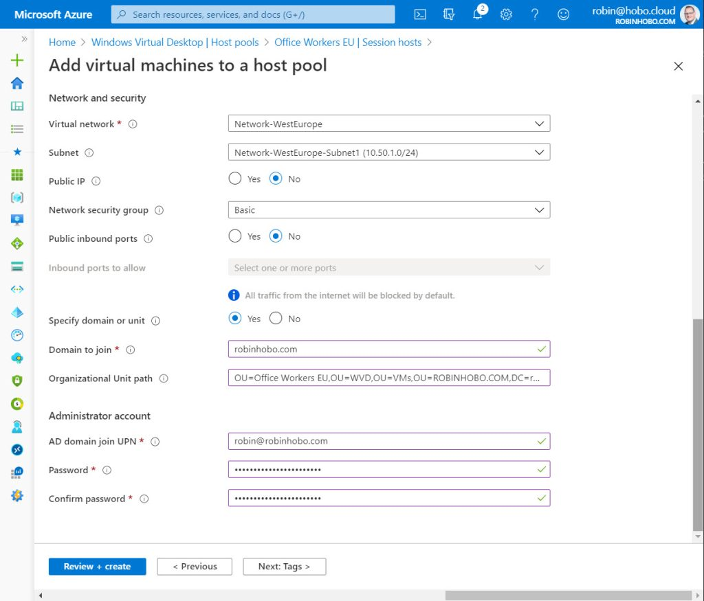](https://robinhobo.com/wp-content/uploads/2020/06/How-to-manage-and-deploy-custom-images-including-versioning-with-the-Azure-Shared-Image-Gallery-SIG-058.jpg)](https://robinhobo.com/wp-content/uploads/2020/06/How-to-manage-and-deploy-custom-images-including-versioning-with-the-Azure-Shared-Image-Gallery-SIG-058.jpg)

Configure your network settings and click **Review + create**

[[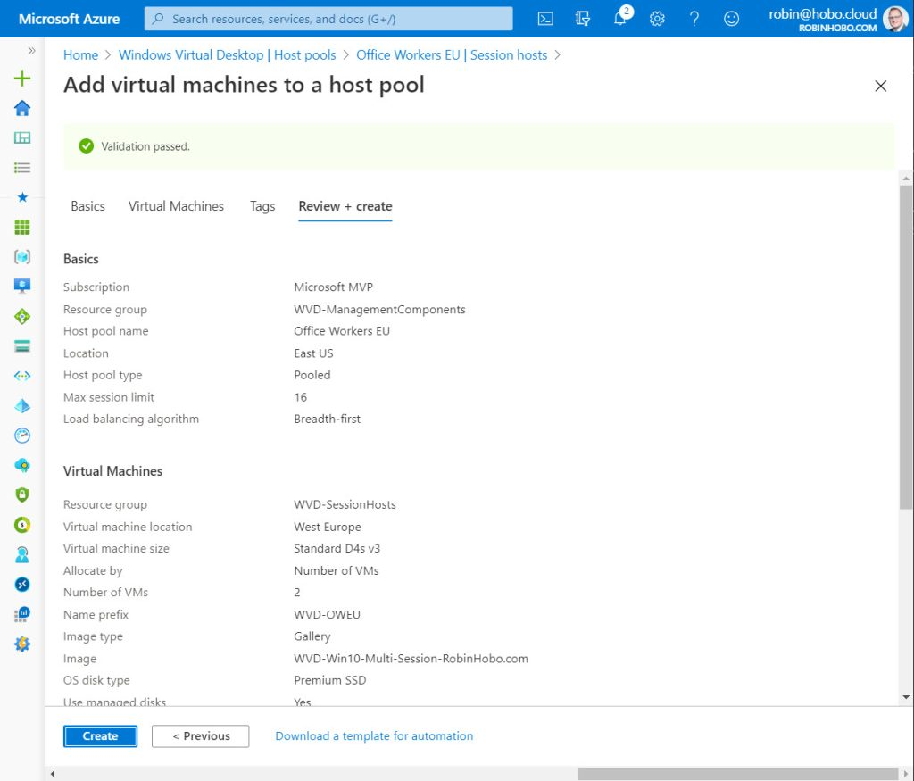](https://robinhobo.com/wp-content/uploads/2020/06/How-to-manage-and-deploy-custom-images-including-versioning-with-the-Azure-Shared-Image-Gallery-SIG-059.jpg)](https://robinhobo.com/wp-content/uploads/2020/06/How-to-manage-and-deploy-custom-images-including-versioning-with-the-Azure-Shared-Image-Gallery-SIG-059.jpg)

Click **Create**

[[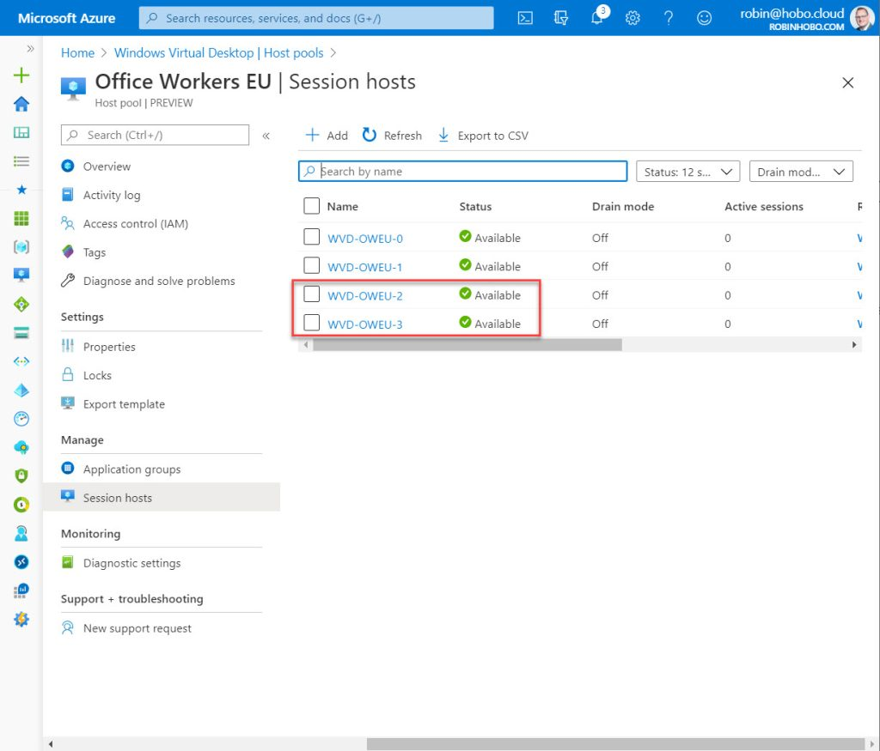](https://robinhobo.com/wp-content/uploads/2020/06/How-to-manage-and-deploy-custom-images-including-versioning-with-the-Azure-Shared-Image-Gallery-SIG-060.jpg)](https://robinhobo.com/wp-content/uploads/2020/06/How-to-manage-and-deploy-custom-images-including-versioning-with-the-Azure-Shared-Image-Gallery-SIG-060.jpg)

After the deployment is finished, the new servers are added to the Windows Virtual Desktop Host pool, created with the latest version of the custom image.

[[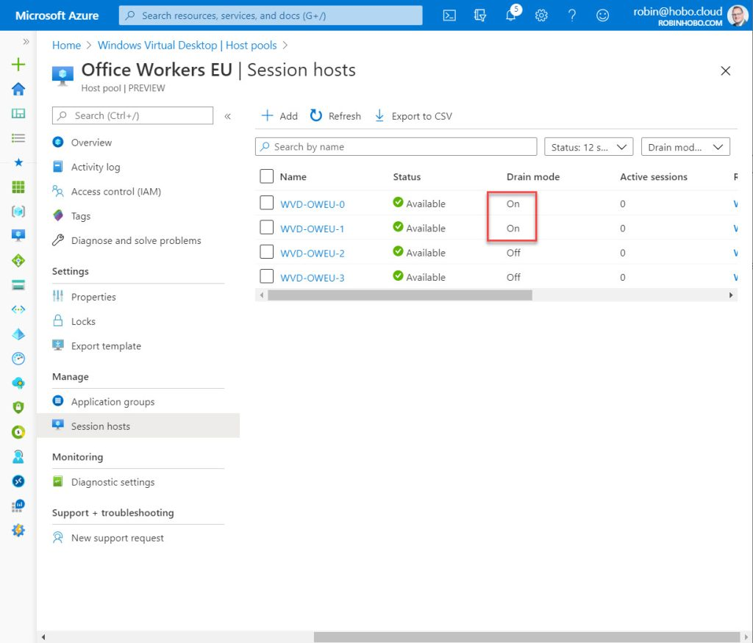](https://robinhobo.com/wp-content/uploads/2020/06/How-to-manage-and-deploy-custom-images-including-versioning-with-the-Azure-Shared-Image-Gallery-SIG-061.jpg)](https://robinhobo.com/wp-content/uploads/2020/06/How-to-manage-and-deploy-custom-images-including-versioning-with-the-Azure-Shared-Image-Gallery-SIG-061.jpg)

Now you can enable the **Drain mode** on the old VMs (VMs created with an old version of the custom image) and test the new version of the custom image. If all tests are successful you can delete the old servers.